



**INSTITUTE FOR ADVANCED**

**COMPUTING AND**

**SOFTWARE DEVELOPMENT**

**AKURDI, PUNE**

Documentation On

**“Delight Kitchen”**

PG-DAC Sept 2022

*Submitted by:*

**Group No: 70**

**Roll No: Name:**

**229152 Goarav Sapkale**

**229156 Jadhav Santosh Madhukar**

**Ms. Manjiri Deshpande Mr. Rohit Puranik**

**Project Guide Center Coordinator**

**ABSTRACT**

This project is a web-based restaurant management system for a specific restaurant. The project objective is to deliver restaurant management applications into web platforms.

This project is an attempt to provide the advantages of using restaurant management applications to a specific restaurant in the real world which intends to manage their restaurant functionality online via using an application. It helps in reducing human effort by maintaining the workflow of a restaurant in online mode, where each staff person working in the restaurant could do their job role efficiently. This system can be implemented to specific restaurants which wish to operate their restaurant functionalities in the online mode via application (specific to particular restaurant).

If the restaurant is using an online system to manage its functionalities then much of human efforts will be reduced and efficient services will be made available to the visited restaurant. If a visiting customer is well satisfied with the service, positive feedback will be given by his side as a result the rating of a restaurant will increase and in future more and more customers will pay a visit.

**ACKNOWLEDGEMENT**

We take this occasion to thank God, almighty for blessing us with his grace and

taking our endeavor to a successful culmination. I extend my sincere and

Heartfelt thanks to our esteemed guide, **Mrs. Manjiri Deshpande** for providing

me with the right guidance and advice at the crucial juncture and for showing me the

right way. I extend my sincere thanks to our respected **Center Co-Ordinator Mr.**

**Rohit Puranik** for allowing us to use the facilities available. I would like to

thank the other faculty members also, at this occasion. Last but not the least, I would

like to thank my friends and family for the support and encouragement they have

given me during the course of our work.

**Goarav Sapkale(229152)**

**Jadhav Santosh Madhukar(229156)**

**Table of Contents**

**1.** **Introduction****1**

Document Purpose 1

Problem Statement 1

Product Scope 2

Aim & Objectives 2

**2. Overall Description** **3**

Product Perspective 3

User and Characteristics 3

Operating Environment 4

Design and Implementation Constraints 5

**3. Requirements Specification** **6**

External Interface Requirements 6

Non-Functional Requirements 7

**4. System Diagram** **8**

Activity Diagram 11

Data Flow Diagram 14

ER Diagram 15

Use Case Diagram 16

**5. Table Structure** **18**

Bills 18

Category 18

OrderItem 18

Orders 18

Product 18

Tables 19

Users 19

**6. Screenshots** **21**

**7. Conclusion** **37**

Future Scope 37

**8. References** **38**

**List of Figures**

Figure 1 Admin Activity Diagram 8

Figure 2 Admin Sequence Diagram 9

Figure 3 Chef Activity Diagram 10

Figure 4 Chef Sequence Diagram 11

Figure 5 Cashier Activity Diagram 12

Figure 6 Waiter Activity Diagram 13

Figure 7 Level 0 Data Flow Diagram 14

Figure 8 ER Data Flow Diagram 15

Figure 9 Use Case Diagram 16

Figure 10 ER Diagram 17

1. **Introduction**

This project is a web-based restaurant management system for a specific existing restaurant. It presents a detailed explanation of the objectives, features, user interface and application of Restaurant Management System(RMS) in real life. It will also describe how the system will perform and under which it must operate. The Restaurant Management System allows the restaurant’s staff along with manager to log in the application where they all can track their work and services that need to be delivered to the visited customer according to their respective job roles. This project attempts to provide the advantages of online restaurant management by reducing human effort and time.

**Document Purpose**

The aim of this document is to explain the functionality of the project developed for Restaurant Management System(RMS). This document provides the flow about how the services are being managed and provided to a customer in an efficient manner whenever he makes a visit to a restaurant.

**Problem Statement**

95% of restaurant operators view the ability to improve guest satisfaction and the quality of the guest experience as one of the biggest benefits one can expect to gain with the right restaurant management. 89% of restaurant operators cite the need to drive increased operational efficiency, including increasing staff productivity and reducing inventory waste, as a key success factor. Hence this application is proposed to overcome the inefficiency of existing restaurant so that manager could be able to manage the workflow and their operations in a better manner.

**Product Scope**

This system will help to manage the restaurant business systematically. In this management system, we have designed a web application that can be used by the Manager along with the staff of that restaurant to manage the food orders given by the customers, so that the manager of that restaurant can monitor and ensure the smooth conduct of the whole system.

This will lead to serving food faster and ultimately a better kitchen place to revisit it again. In addition to this, the system is capable of hiring different job roles required for a restaurant, the required information about staff will be saved in the system which can be only accessed by the system admin.

**Aim & Objectives**

Specific goals are: -

* To produce a web-based system that allows the admin to manage whole restaurant functionalities efficiently.
* To ease different staff member to service their respective work and functionalities.
* The main aim of this web application is to reduce human efforts and time by providing multiple features in an online mode that so restaurant owner can run their business smoothly.

**2. Overall Description**

**Product Perspective**

**Users and Characteristics**

In our application we have mainly 4 users, which are the staff members working in that particular restaurants having specific job role.

* There are various role in a restaurant
* **Manager**
* **Chef**
* **Cashier**
* **Waiter**
* Functionalities of different roles:
* Manager

➢ Add/Manage food Category(availability)

➢ Add/Manage food items under available Category

➢ Add/Manage Tables

➢ Add/Manage Staffs

➢ Add/Manage Orders

➢ Billing of Orders

➢ Can change his profiles details

● Chef

➢ Add/Manage food Category(availability)

➢ Add/Manage food items under available Category

➢ Manage Orders

➢ Can change his profiles details

● Cashier

➢ Billing of Orders

➢ Can view history of previous orders

➢ Can change his profiles details

● Waiter

➢ Add/Manage Orders

➢ Can change his profiles details

**Operating Environment**

* **Server Side**

**Processor:** Intel® Xeon® processor 3500 series

**HDD:** Minimum 500GB Disk Space

**RAM:** Minimum 2GB

**OS:** Windows 8.1, Linux 6

**Database:** MySql

* **Client Side (minimum requirement)**

**Processor:** Intel Dual Core

**HDD:** Minimum 250GB Disk Space

**RAM:** Minimum 2GB

**OS:** Windows 10, Linux

**Design and Implementation Constraints**

* The application will use Ajax, JavaScript, jQuery and css as main web technologies.
* HTTP and FTP protocols are used as communication protocols. FTP is used to upload the web application in live domain and the client can access it via HTTP protocol.
* Several types of validations make this web application a secured one and SQL Injections can also be prevented.
* Since Restaurant Management system is a web-based application, internet connection must be established.
* The Society Management System will be used on PCs and will function via internet or intranet in any web browser.

**3. Specific Requirement**

**External Interface Requirements**

* **User Interfaces**
* All the users will see the same page when they enter in this website. This page asks the users a username and a password.
* After being authenticated by correct username and password, user will be redirect to their corresponding profile where they can do various activities.
* The user interface will be simple and consistence, using terminology commonly understood by intended users of the system. The system will have simple interface, consistence with standard interface, to eliminate need for user training of infrequent users.
* **Hardware Interfaces**
* No extra hardware interfaces are needed.
* The system will use the standard hardware and data communication resources.
* This includes, but not limited to, general network connection at the server/hosting site, network server and network management tools.
* **Application Interfaces**

**OS :** Windows 7, Linux

**Web Browser :**

The system is a web-based application; clients need a modern web browser such as Mozilla Firebox, Internet Explorer, Opera, and Chrome. The computer must have an Internet connection in order to be able to access the system.

**Communications Interfaces**

* This system uses communication resources which includes but not limited to, HTTP protocol for communication with the web browser and web server and TCP/IP network protocol with HTTP protocol.
* This application will communicate with the database that holds all the booking information. Users can contact with server side through HTTP protocol by means of a function that is called HTTP Service. This function allows the application to use the data retrieved by server to fulfill the request fired by the user.

**4. System Design**

**Activity Diagram**

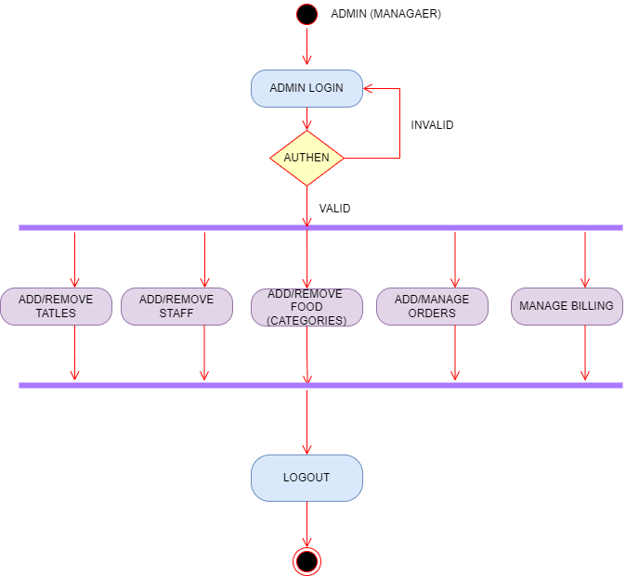

***Figure 1.1: Admin Activity Diagram***

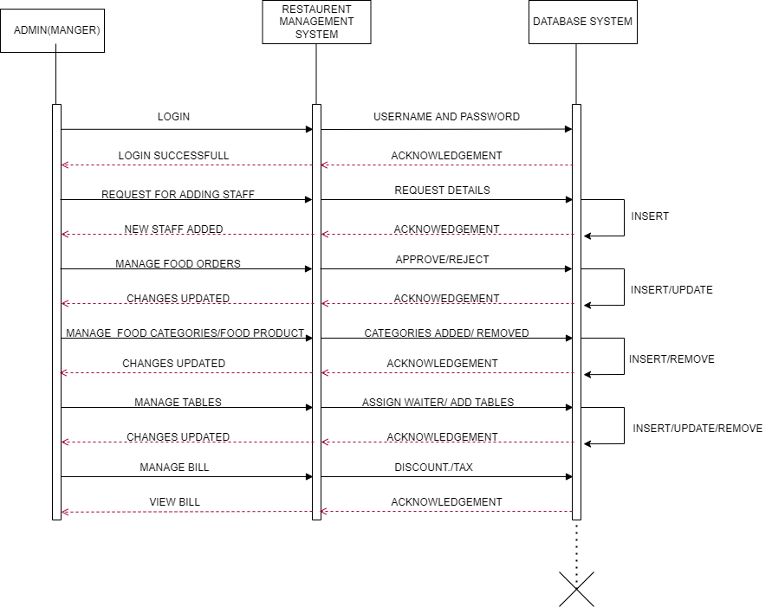

***Figure 1.2: Admin Sequence Diagram***

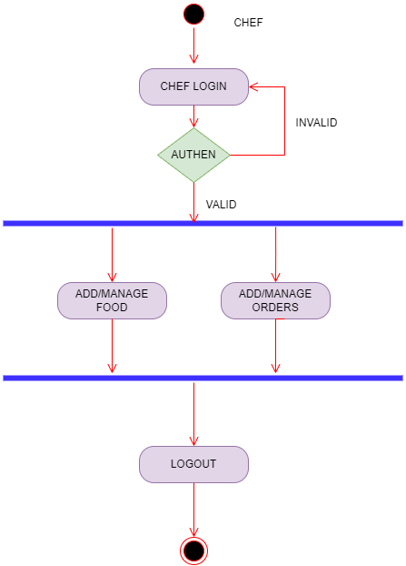

***Figure 2.1: Chef Activity Diagram***

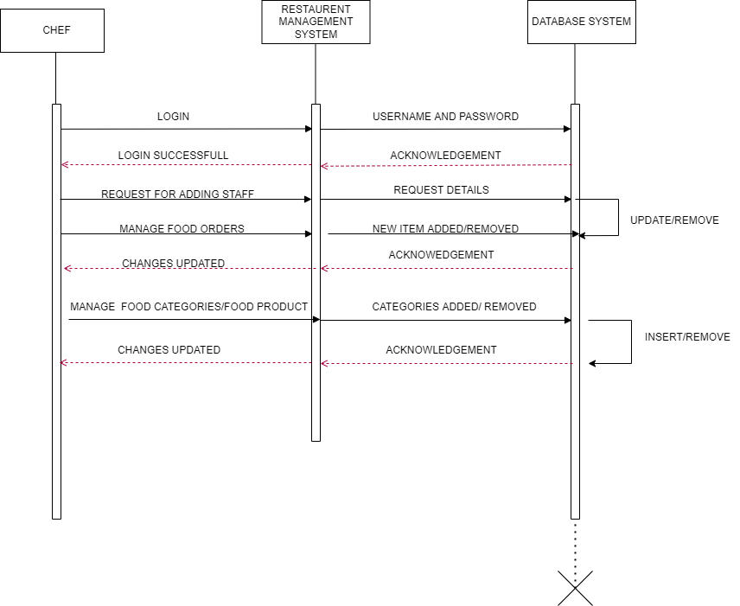

***Figure 2.2: Chef Sequence Diagram***

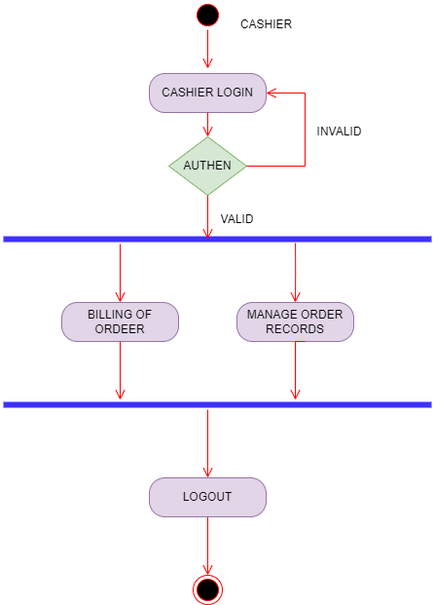

***Figure 3: Cashier Activity Diagram***

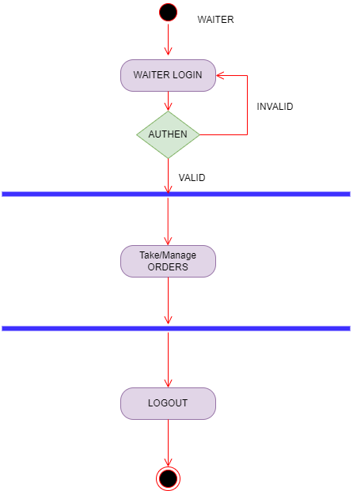

***Figure 4: Waiter Activity Diagram***

**Data Flow Diagram**

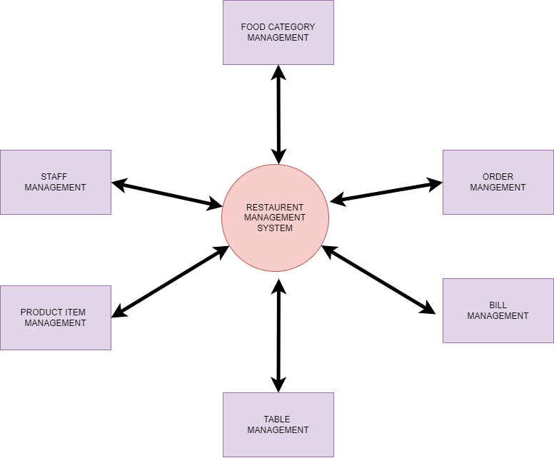

***Figure 5: Level 0 Data Flow Diagram***

**ERD Flow Diagram**

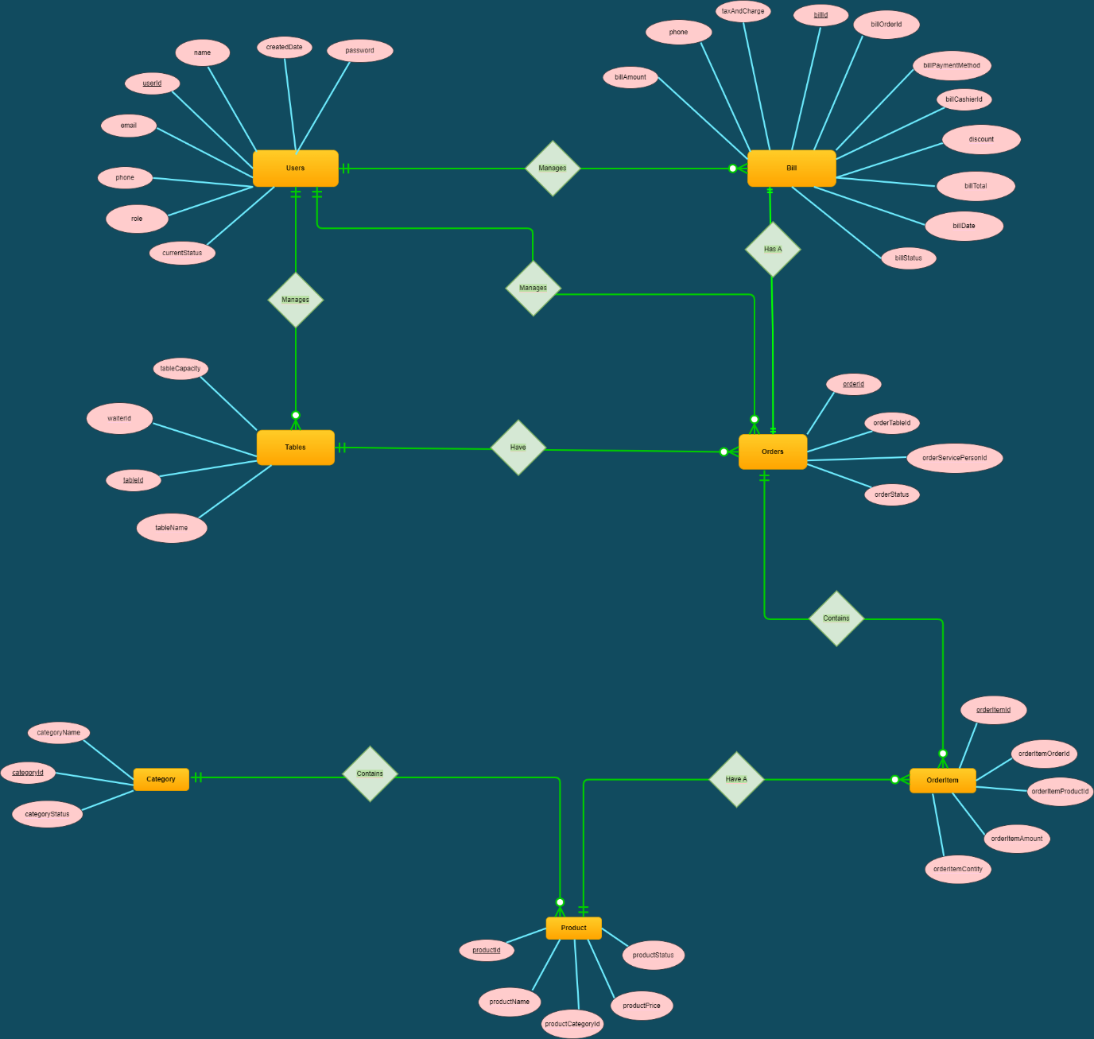

***Figure 6: ER Data Flow Diagram***

**Use Case Diagram**

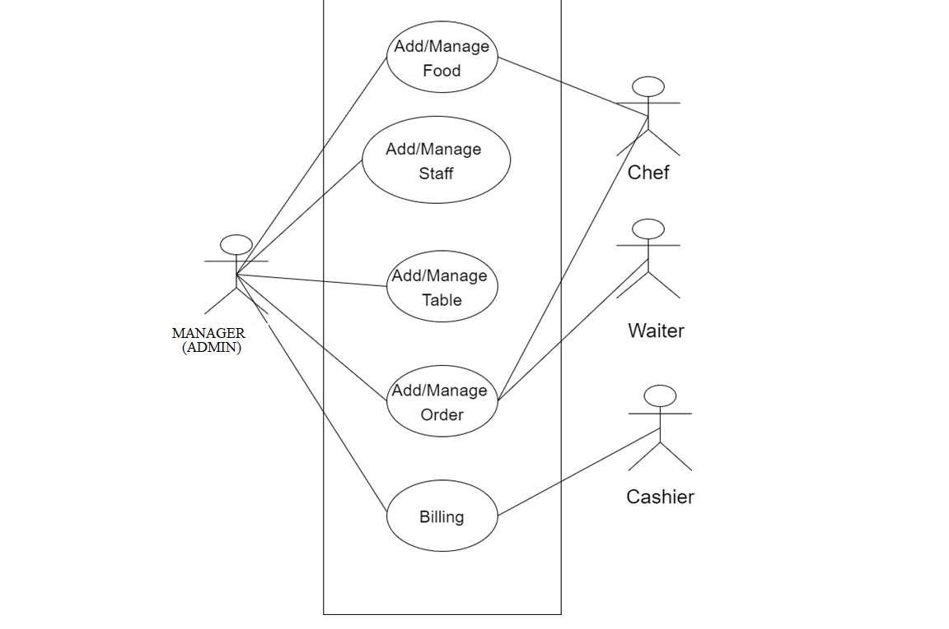

***Figure 7: Use Case Diagram***

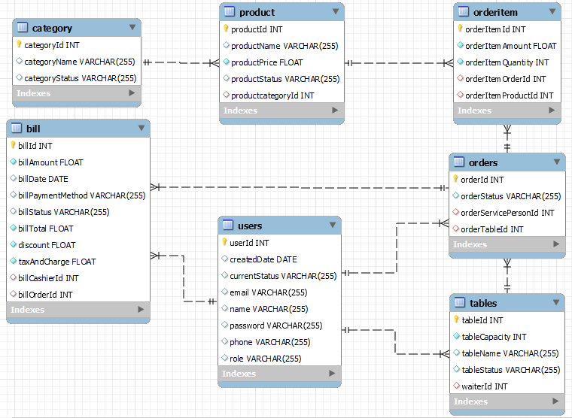

***Figure 8: ER Diagram***

**5. Table Structure**

**Bill:**

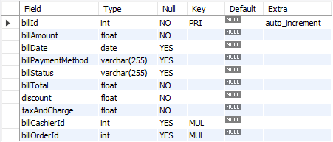

**Category:**

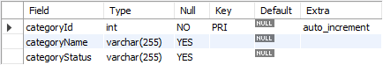

**OrderItem:**

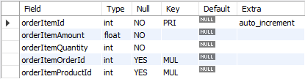

**Orders:**

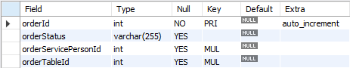

**Product:**

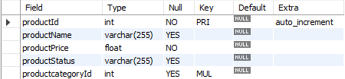

**Tables:**

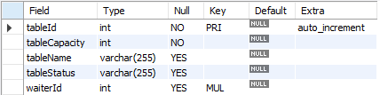

**Users:**

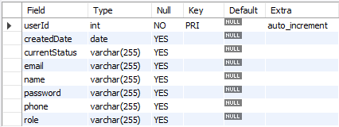

**LOGIN SECTION FOR MANAGER**

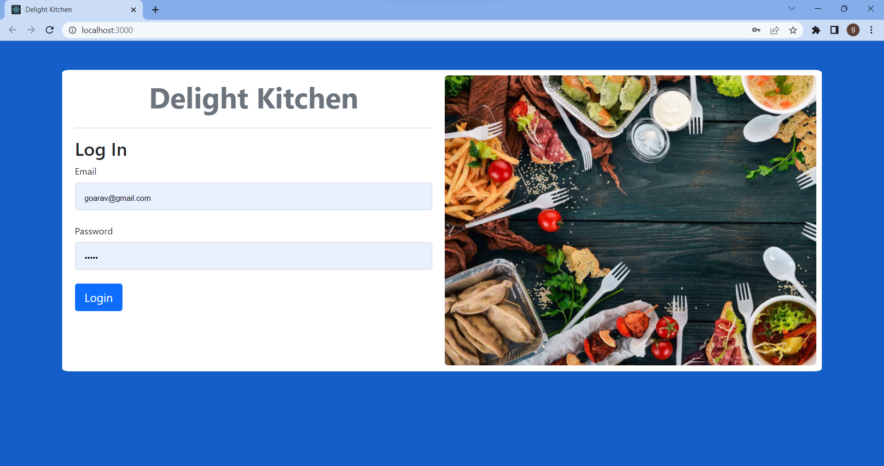

**DASHBOARD OF MANAGER**

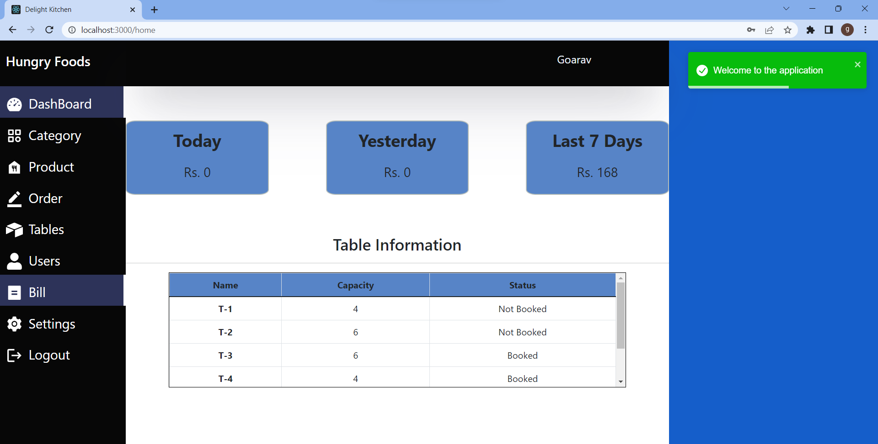

**SCREEN OF MANAGER( GOARAV) OF HUNGRY FOODS RESTAURANT**

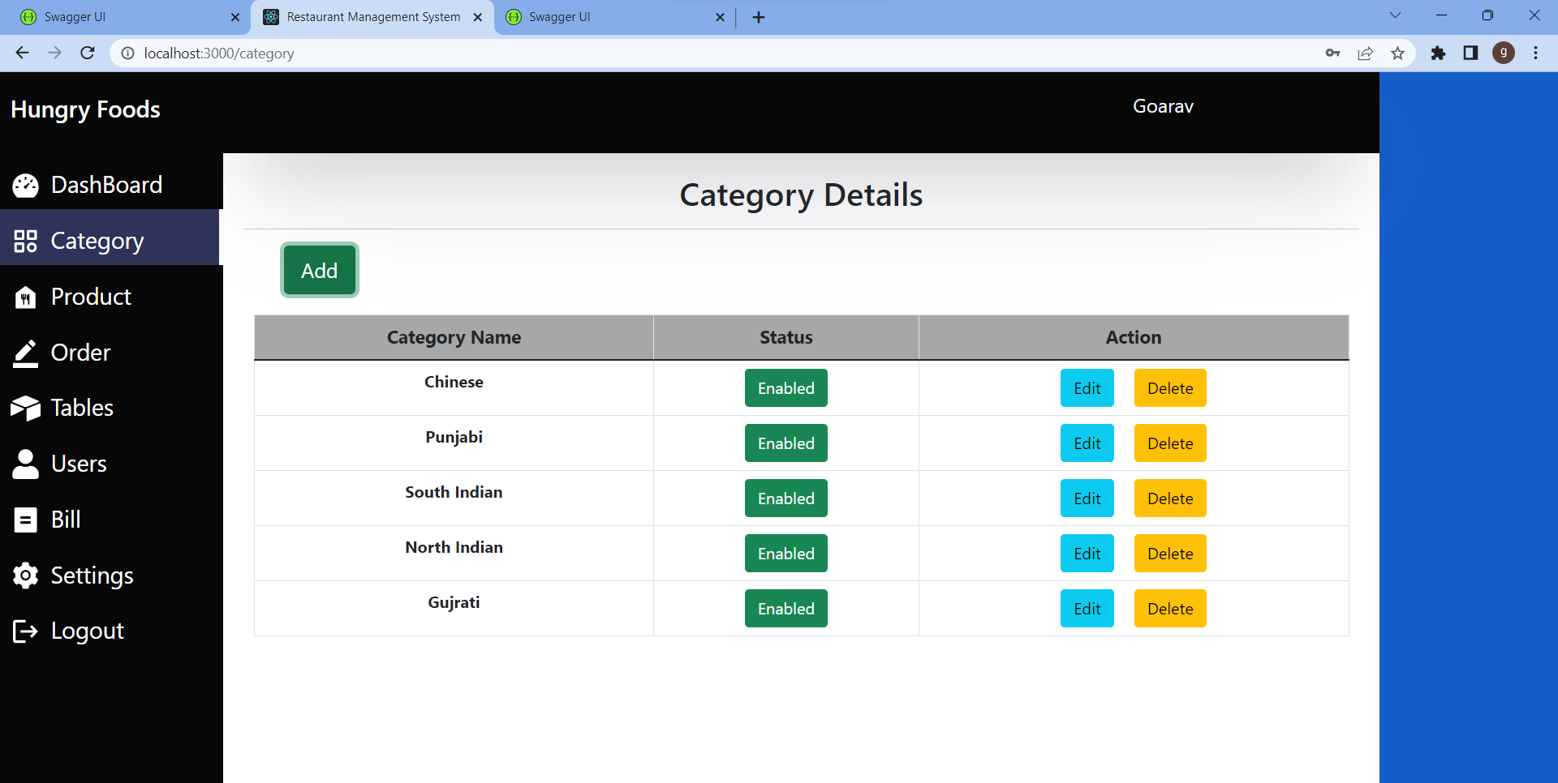

**STAFF OF RESTAURANT(USERS) WHO CAN ACCESS THE APPLICATION**

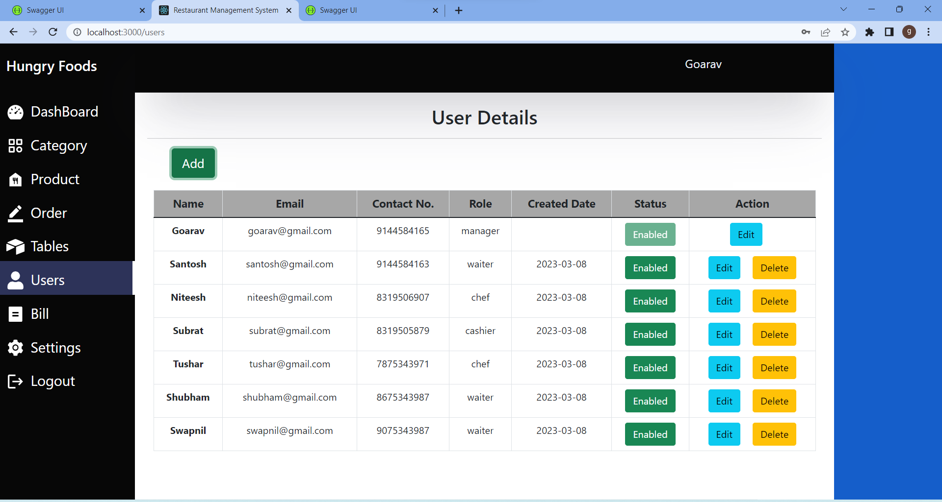

**ADDITION OF NEW STAFF MEMBER(CASHIER) BY MANAGER**

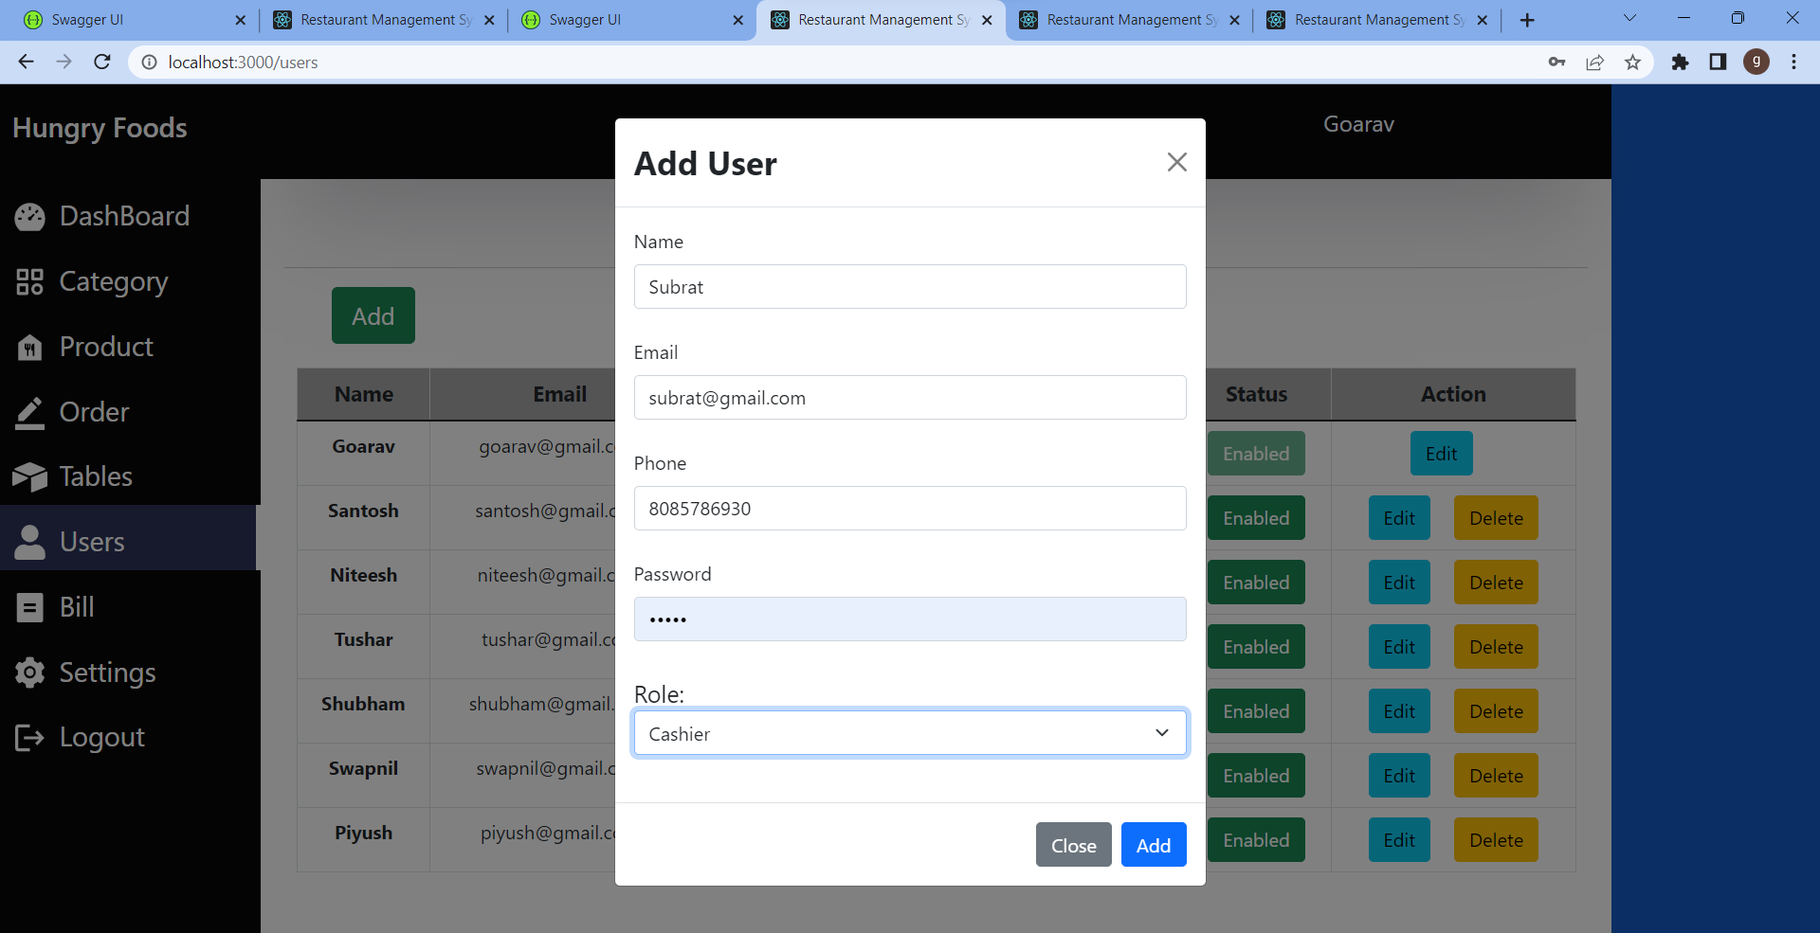

**ADDED STAFF MEMBER (CASHIER) DISPLAYED UNDER USER**

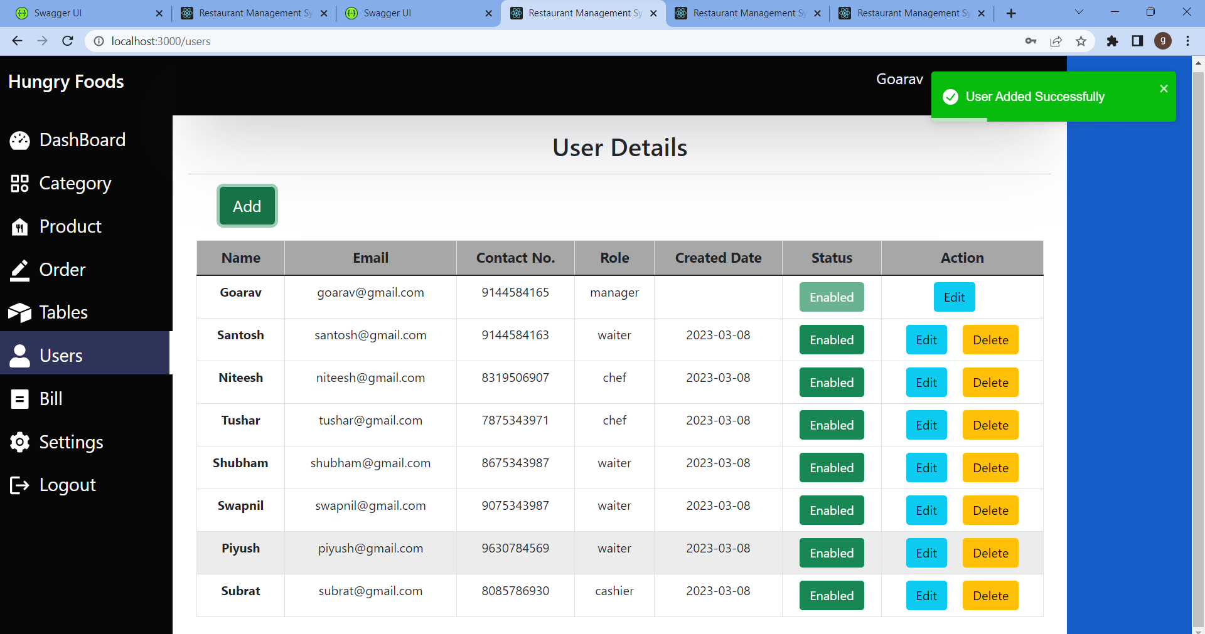

**MANAGER CAN TEMPERORY DISABLED/ENABLED STAFF**

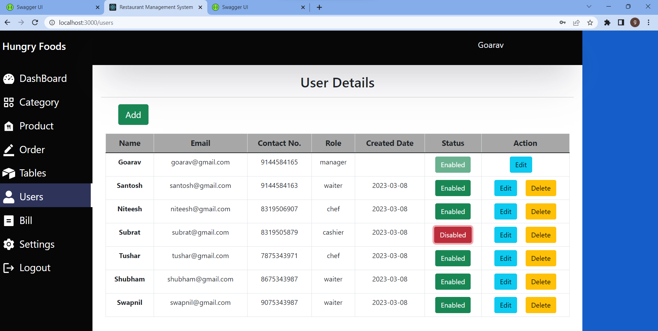

**DETAILS OF STAFF (CASHIER) UPDATED AND DELETED BY MANAGER**

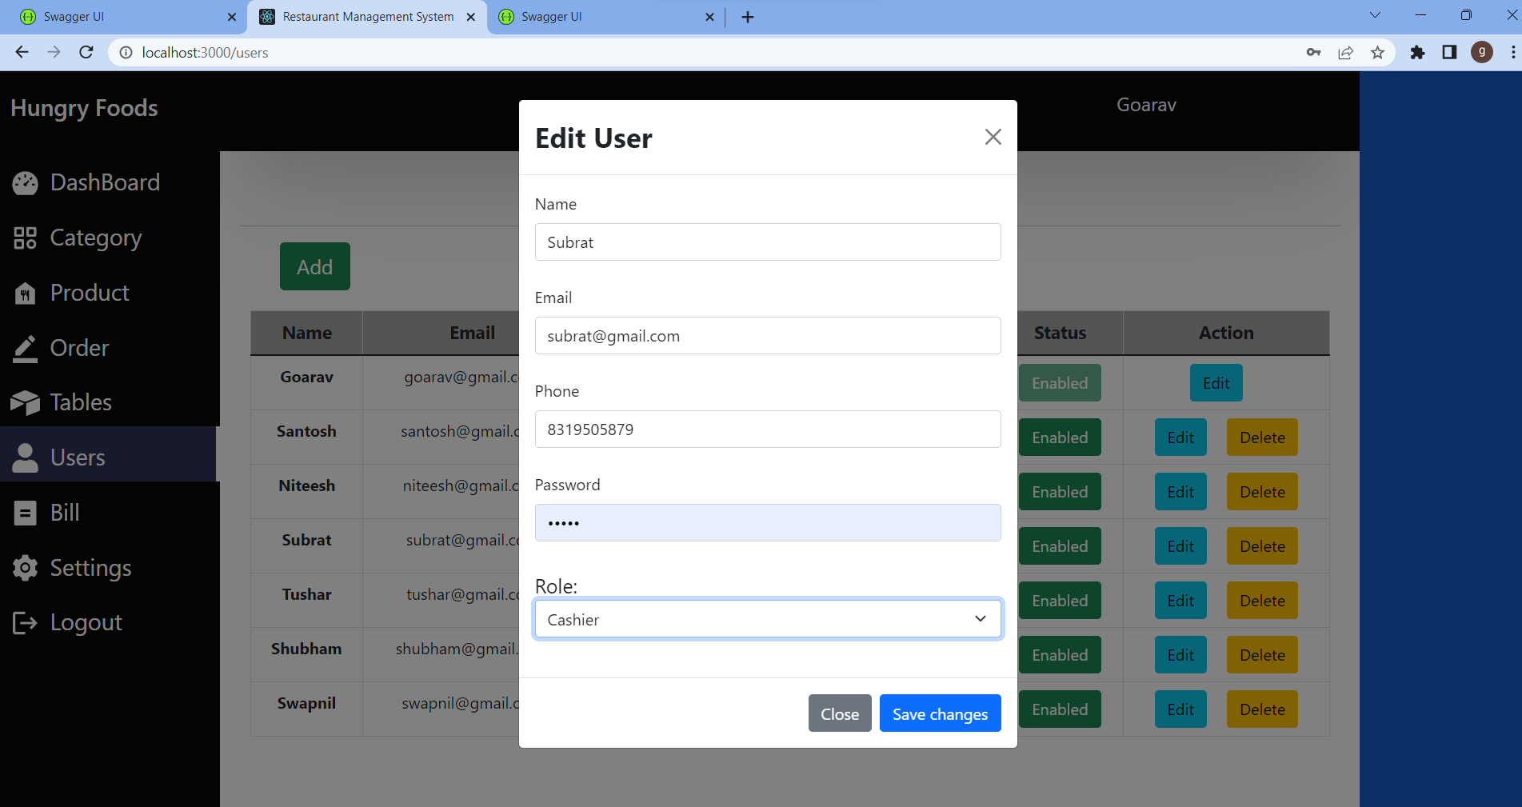

**MANAGER CAN UPDATE HIS PASSWORD OR DETAILS FROM SETTINGS SECTION**

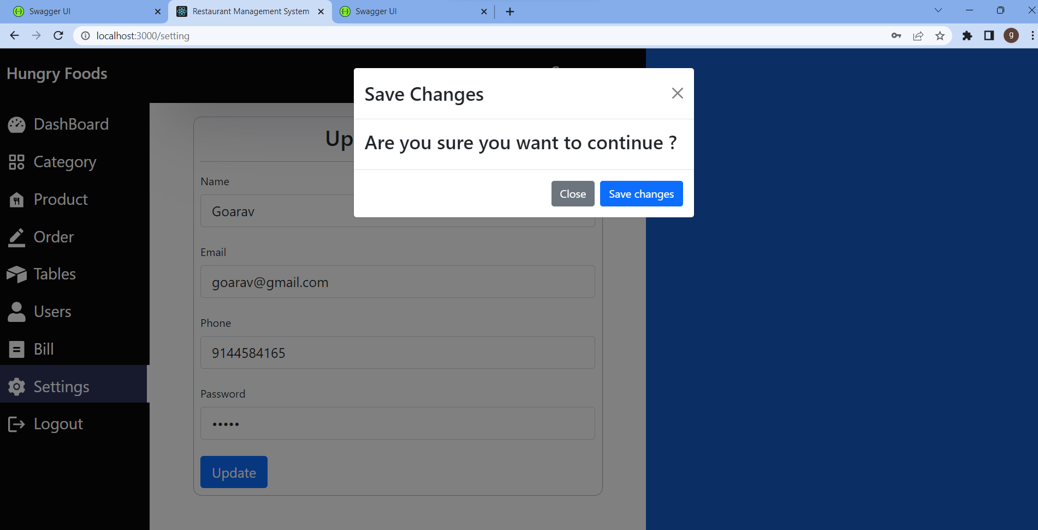

**NOW ENTERED NEW CREDENTIAL TO LOG IN AS MANAGER**

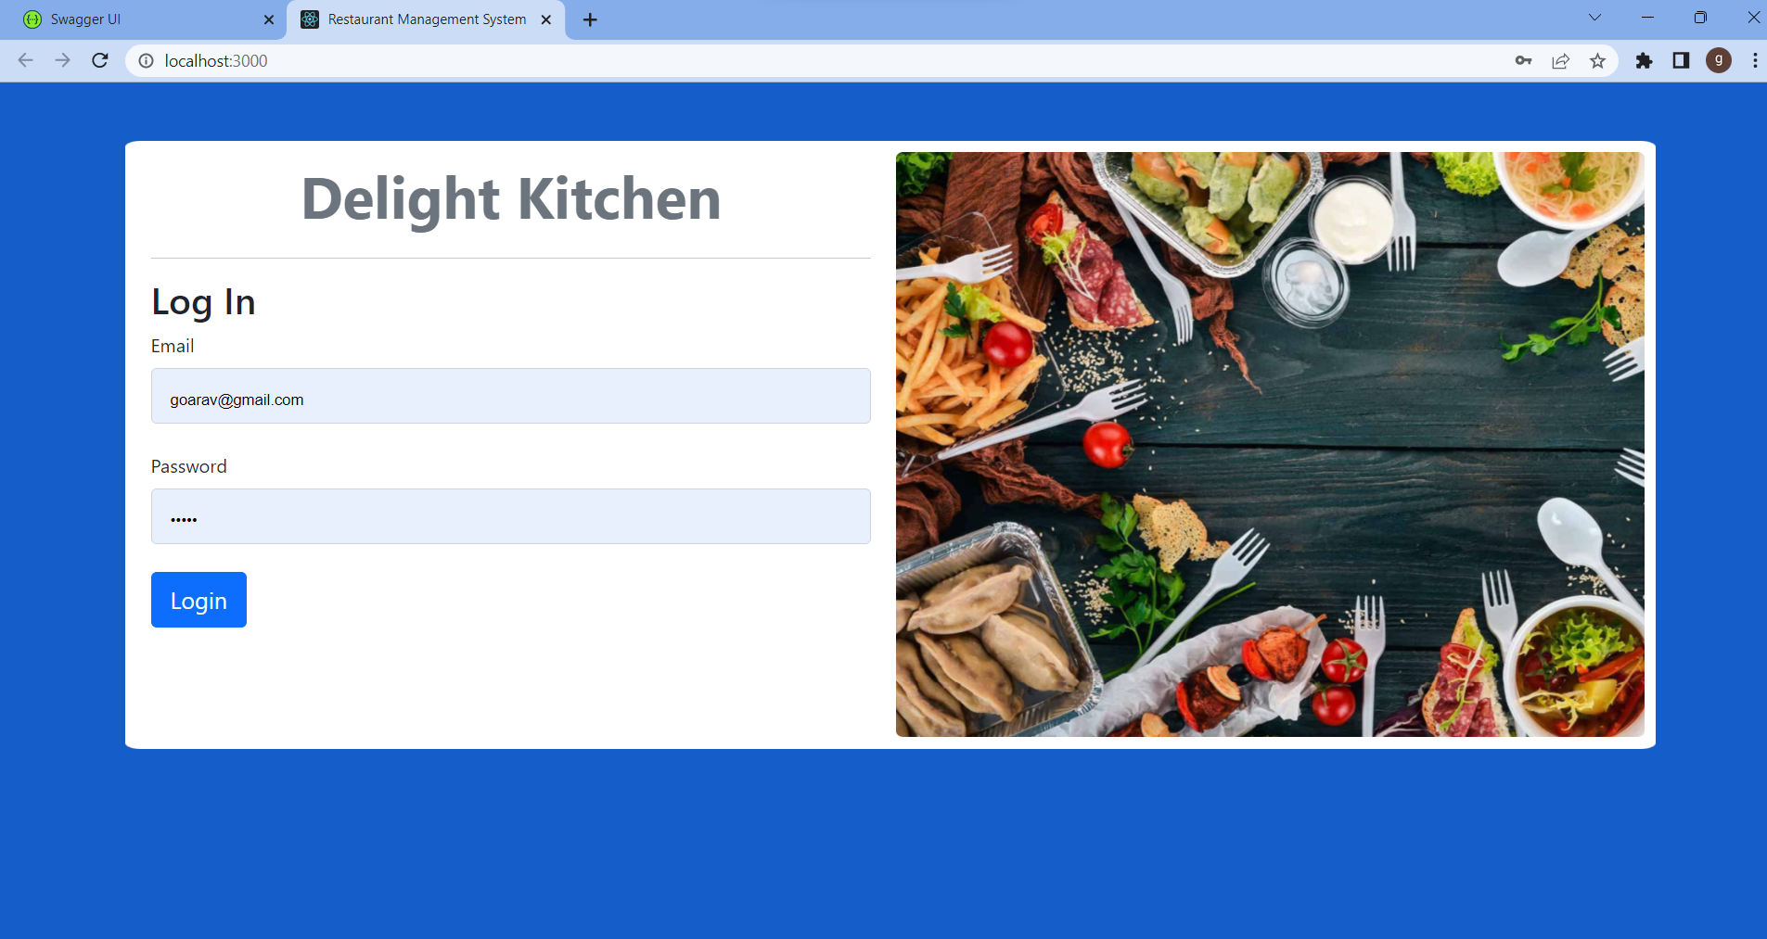

**TABLES SECTION WHERE MANAGER CAN ASSIGN TABLES TO WAITERS**

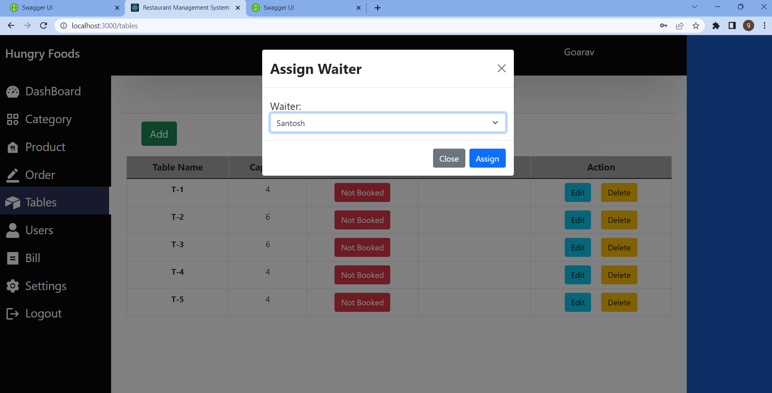

**ADDING NEW TABLES WITH CAPACITY BY MANAGER**

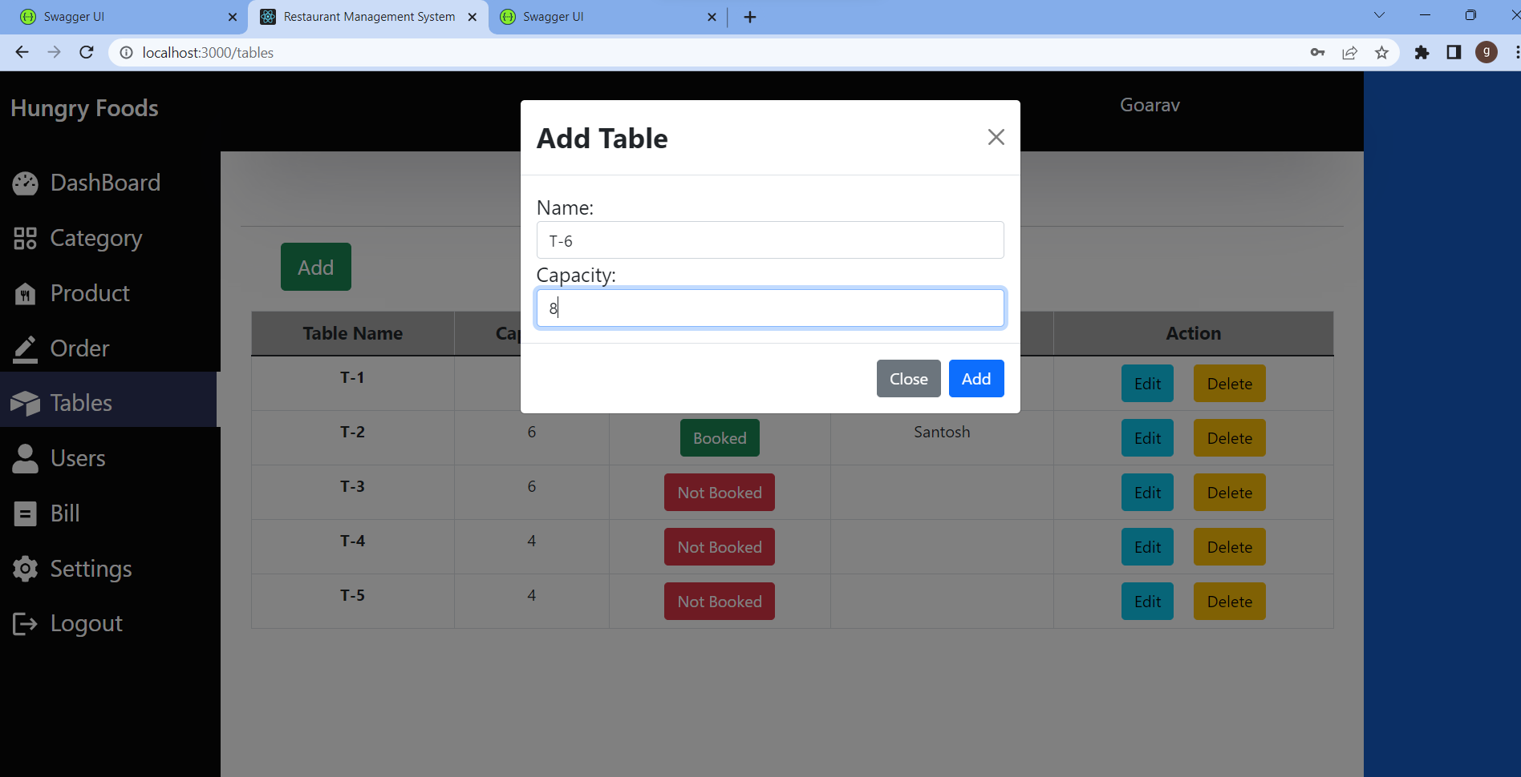

**NEW TABLE T-6 ADDED BY MANAGER which is yet to be assign to Waiter**

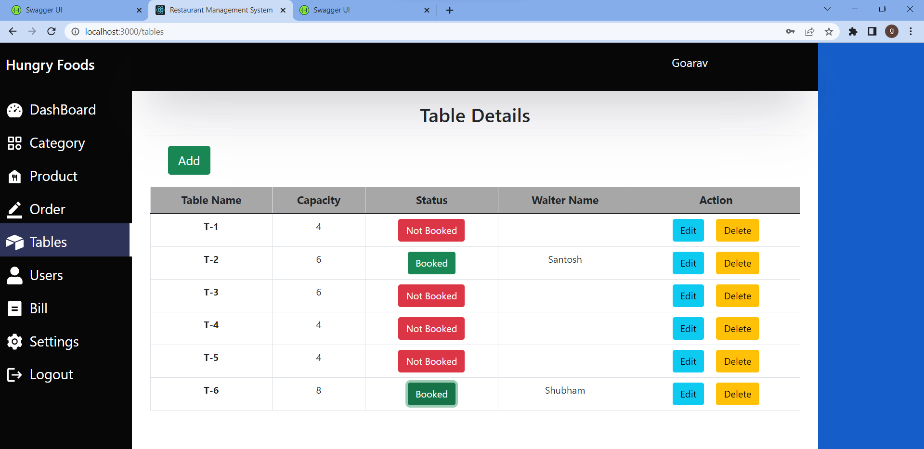

**TABLE ASSIGNED BY MANAGER TO WAITER**

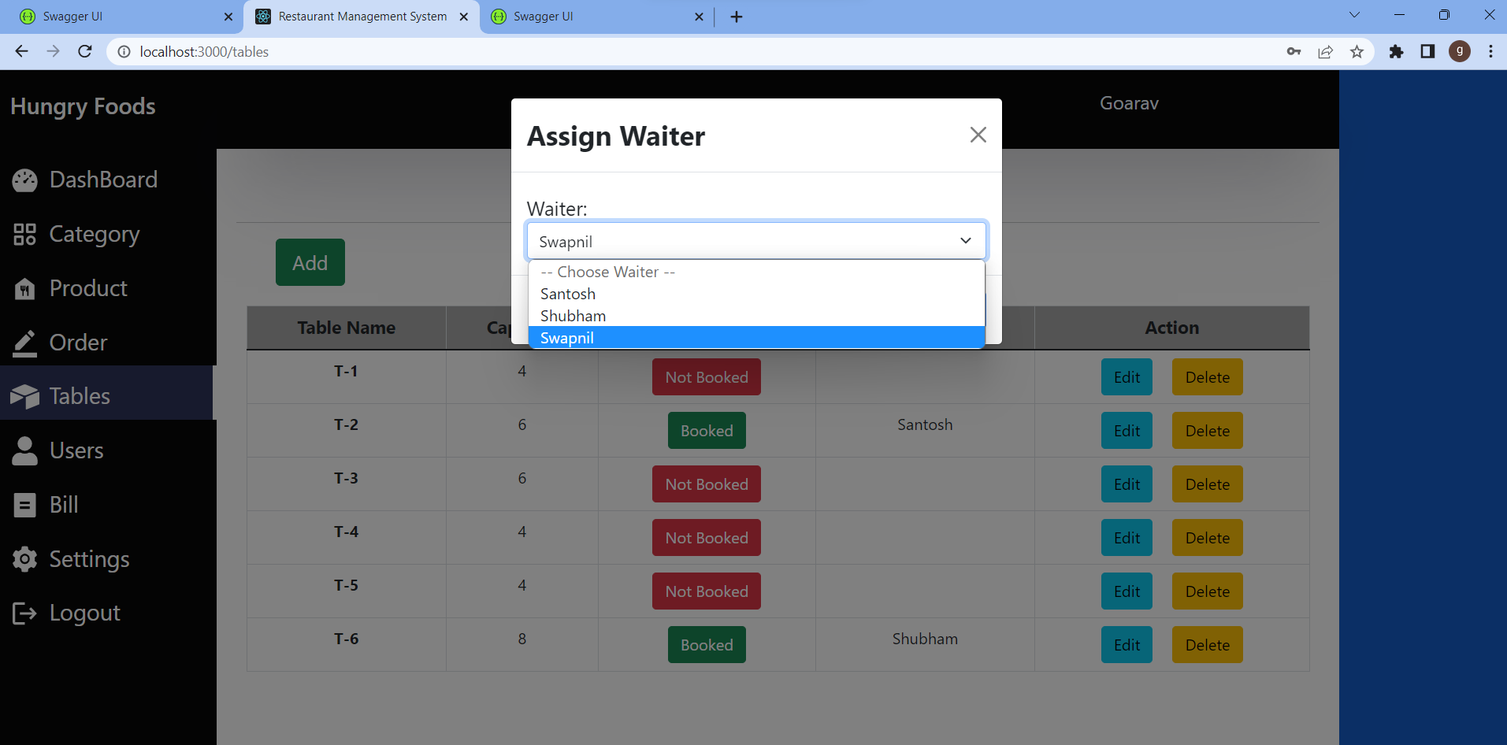

**NOW LOGIN BY WAITER**

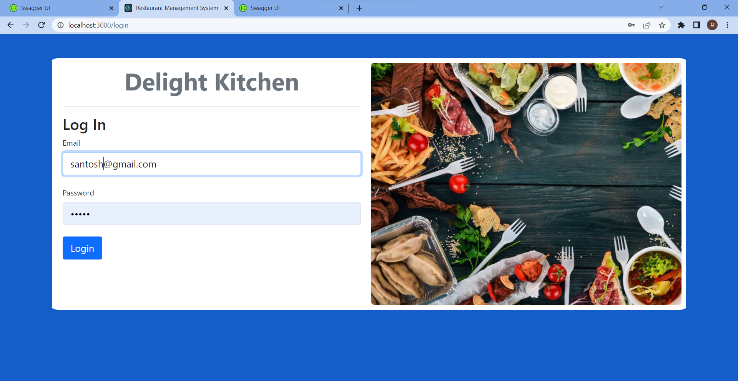

**USER INTERFACE OF WAITER**

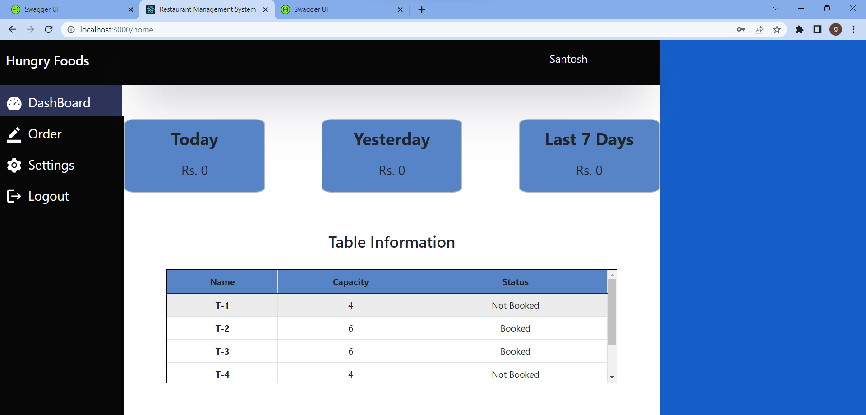

**ORDER TAKING BY WAITER OF T-2 TABLE CUSTOMERS**

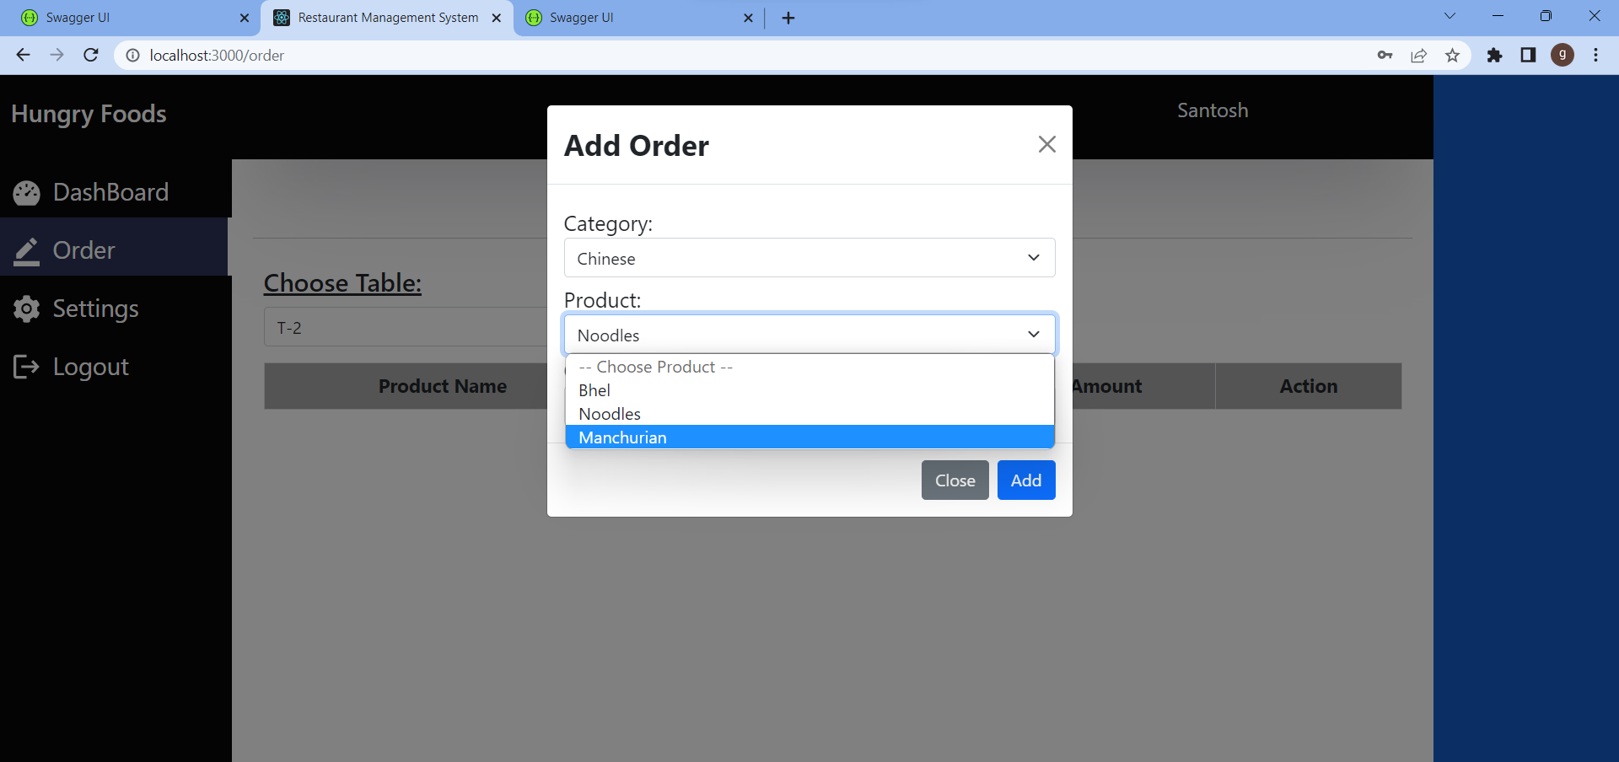

**ORDERS TAKEN BY WAITEER FROM T-2 TABLE WHICH WILL BE HANDELED BY CHEF**

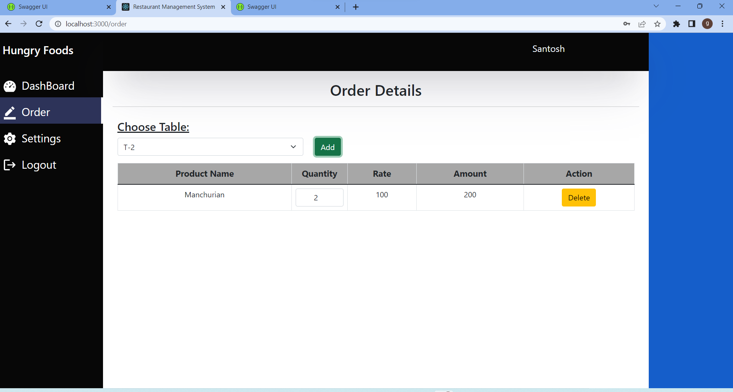

**WAITER CAN CHANGE HIS PASSWORD , NAME OR USER ID FROM SETTING SECTION**

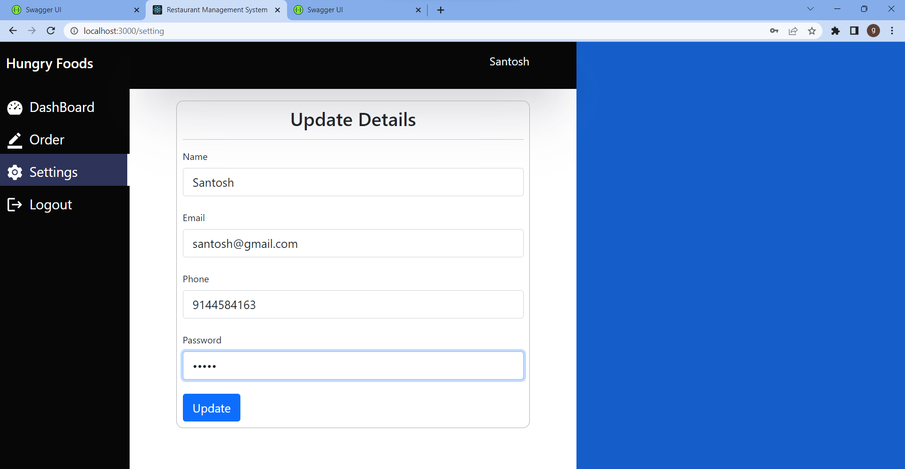

**CHEF (Niteesh Sati) logged in**

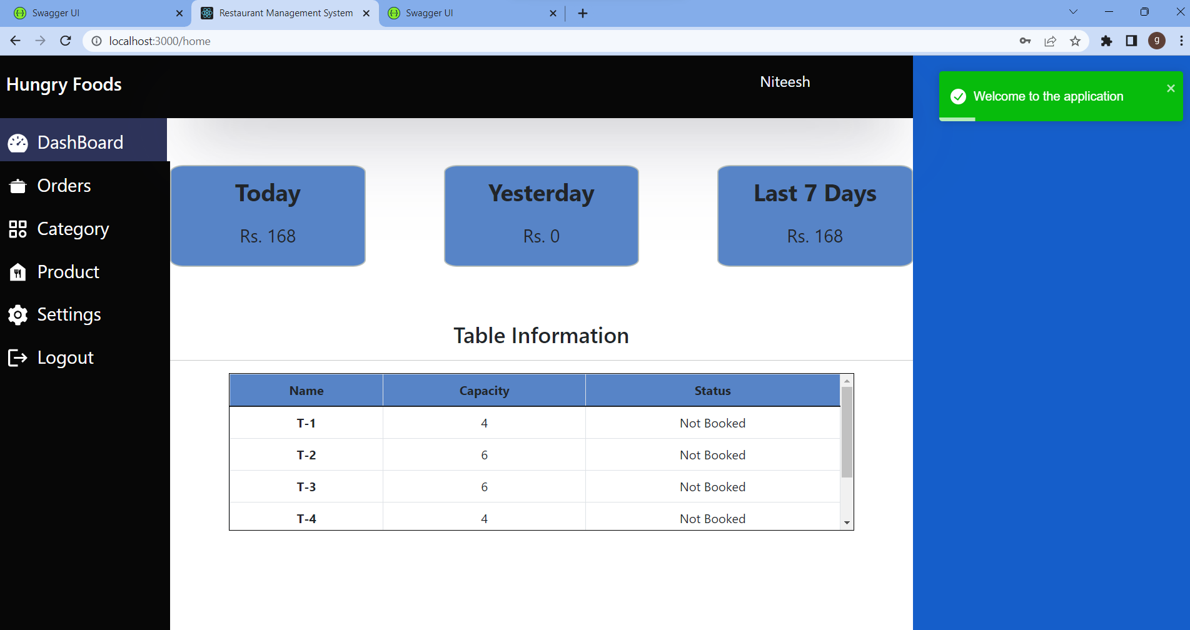

**CHEF CAN SEE PENDING ORDER LIST**

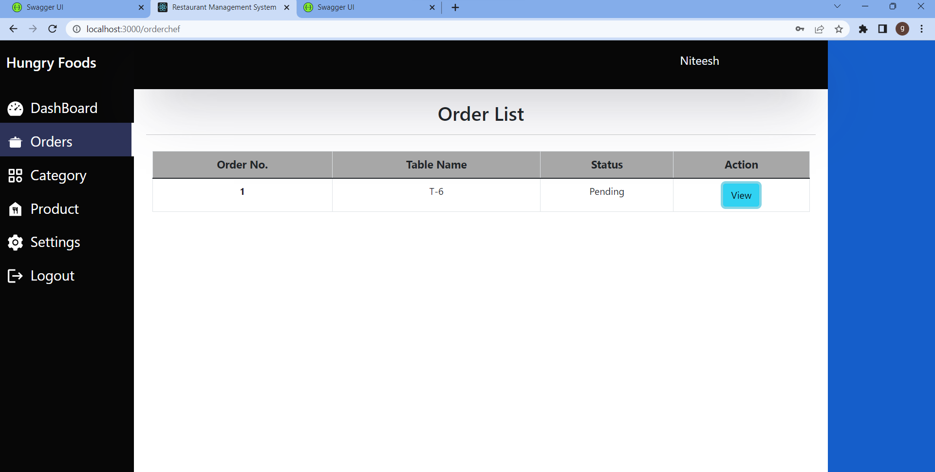

**CHEF CAN MANAGE APPROVE/ COMPLETE ORDER**

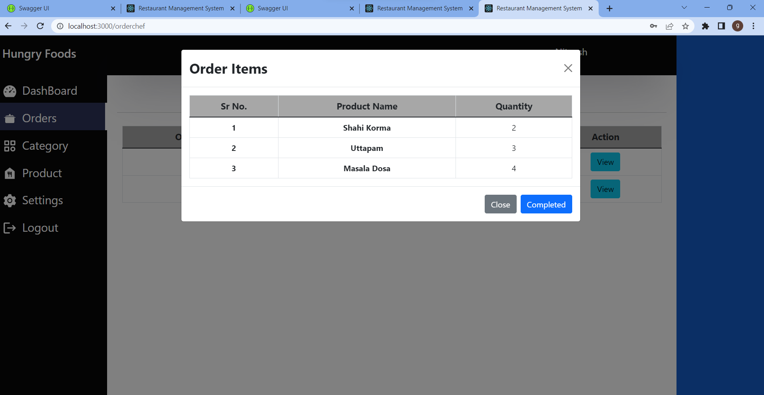

**CHEF CAN ADD/DELETE/DISABLE/ENABLE /EDIT FOOD CATEGORIES**

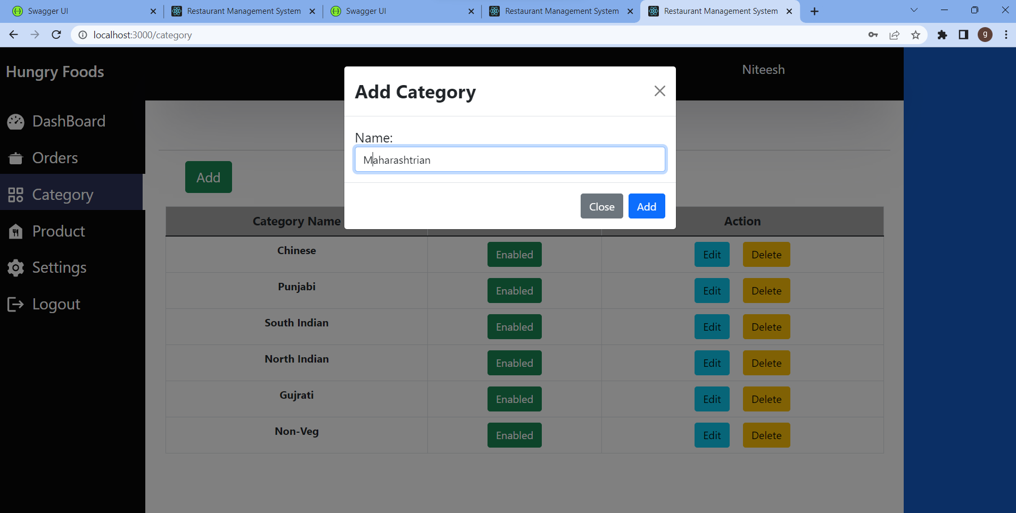

**CHEF CAN ADD/DELETE FOOD PRODUCT**

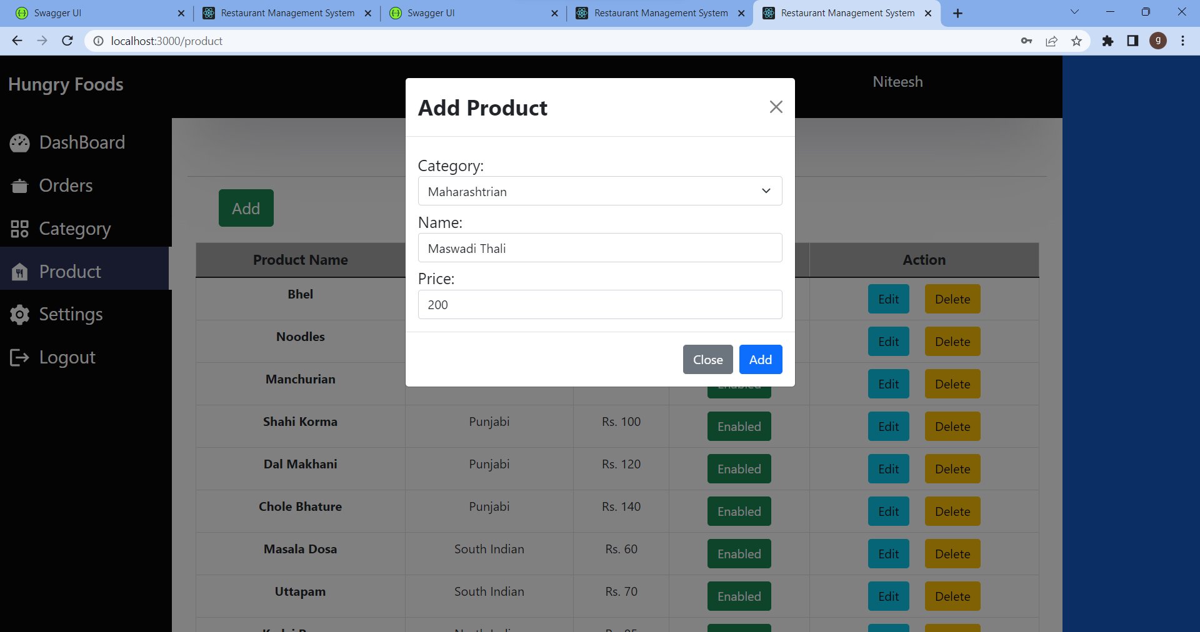

**Maharashtrian FOOD PRODUCT MASWADI THALI ADDED BY CHEF KHANDVI DISABLED BY CHEF DUE TO ANAVAILABILITY**

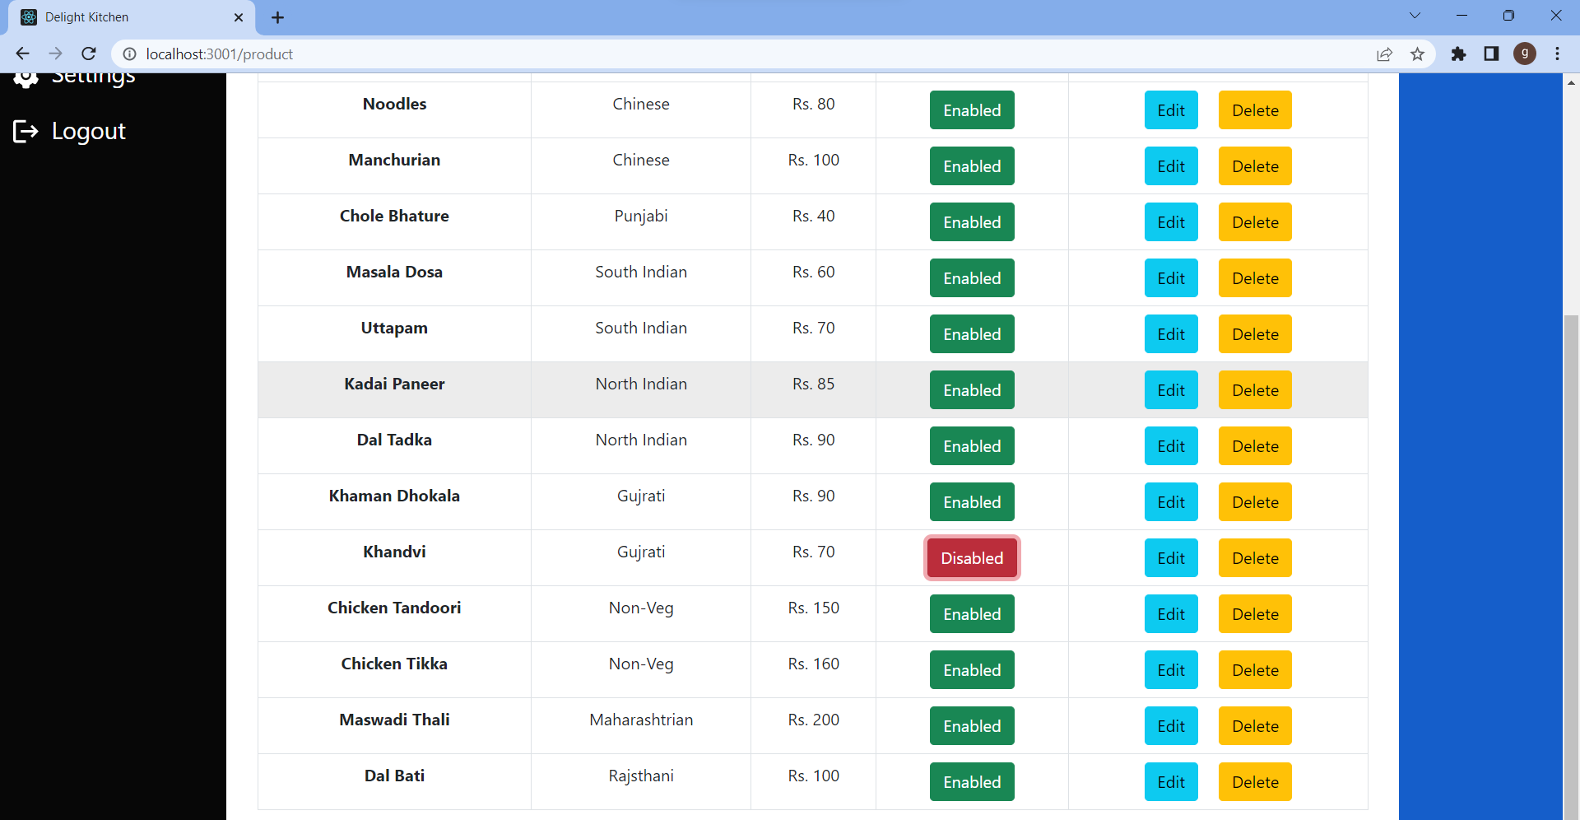

**Subrat Gupta LOG IN AS A CASHIER USING CREDIENTIAL**

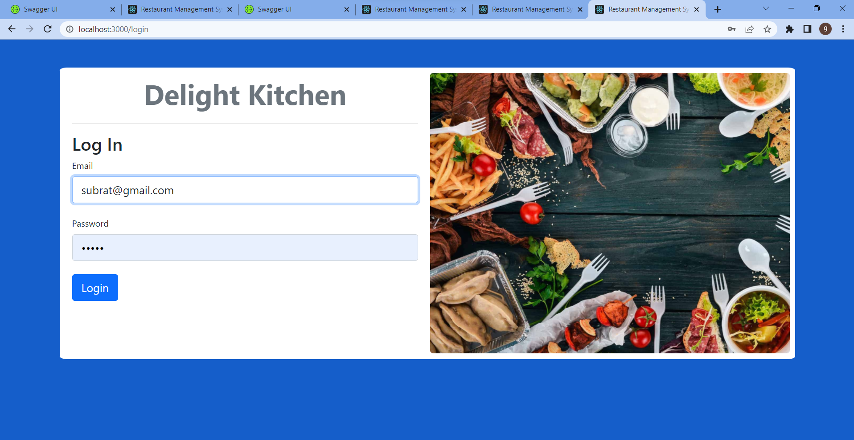

**DASHBOARD OF CASHIER**

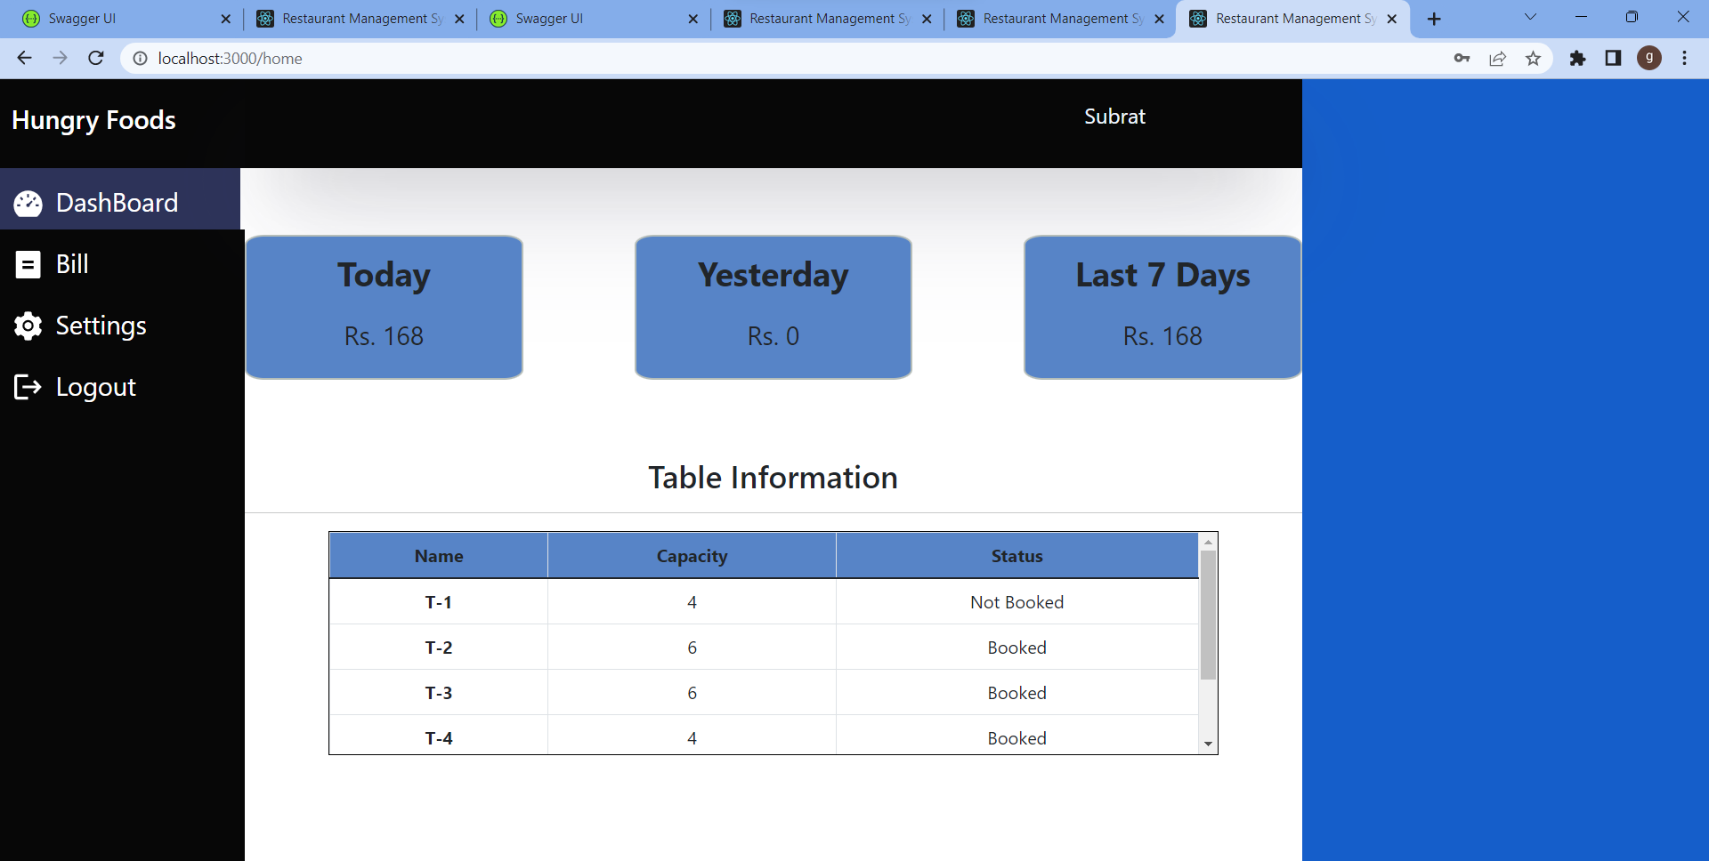

**CAHIER CAN VIEW COMPLETED AND PENDING PAYMENT BILLS**

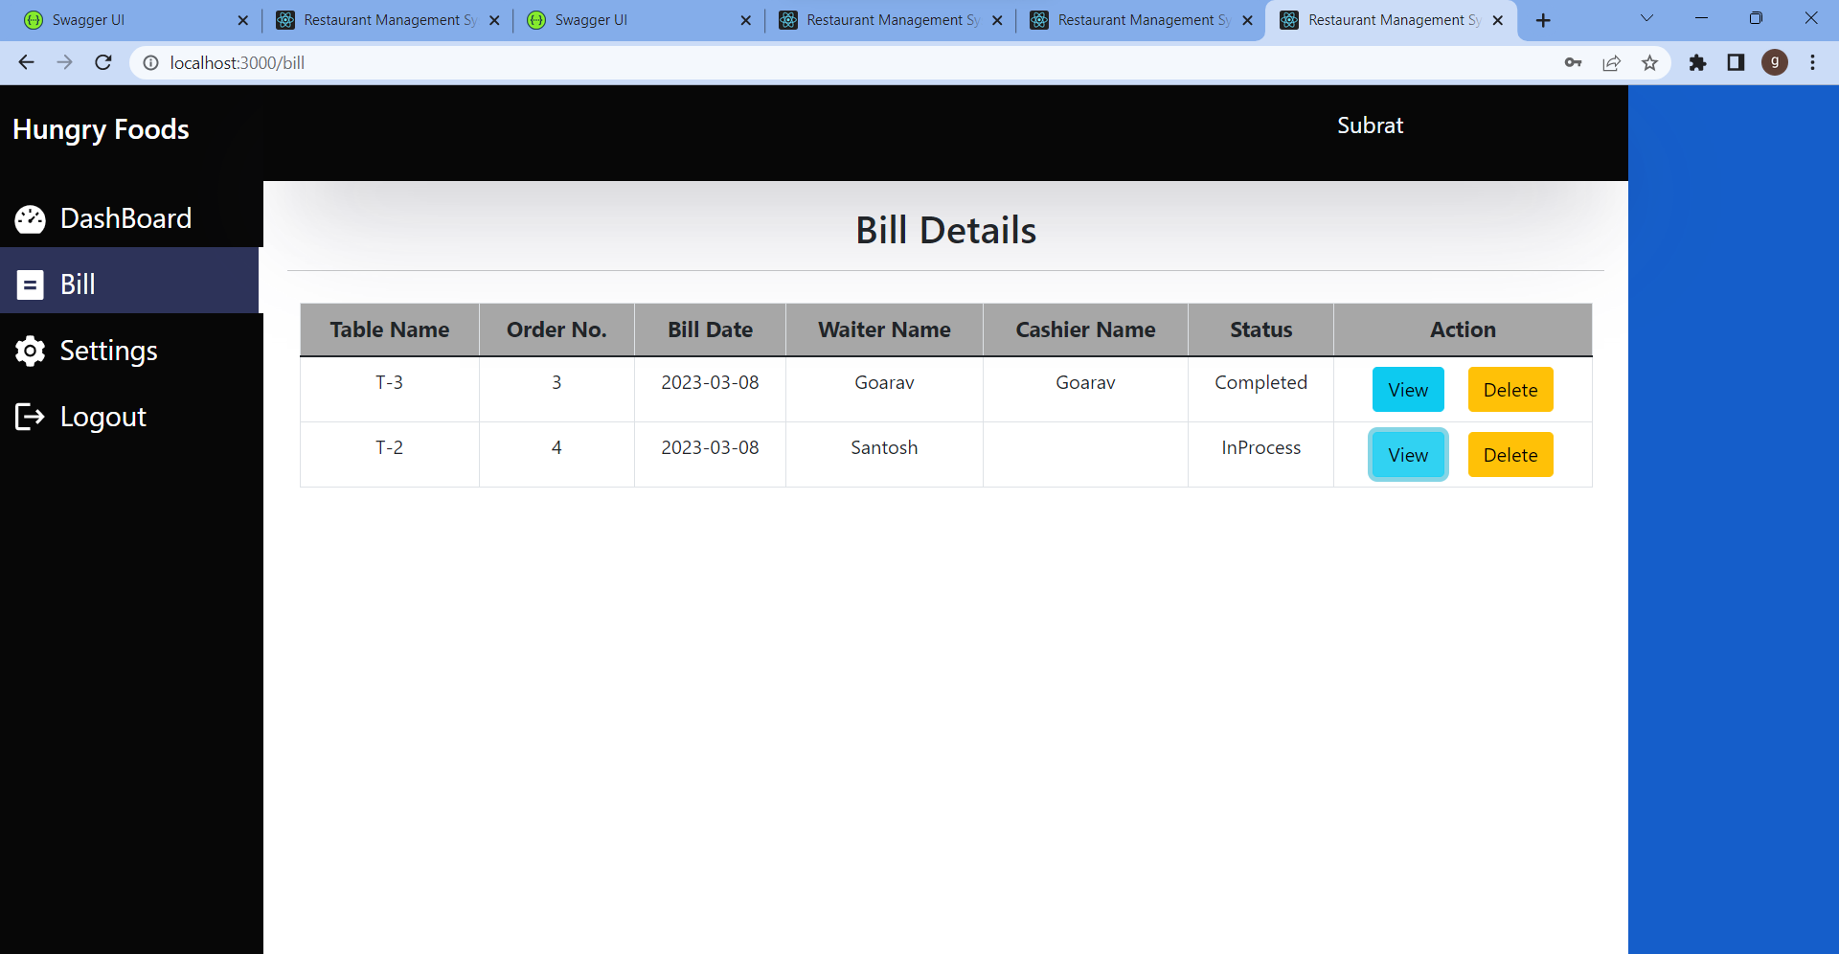

**CAHIER CAN GENERATE BILLS WITH APPLY DISCOUNTS (if needed) AND TAXES**

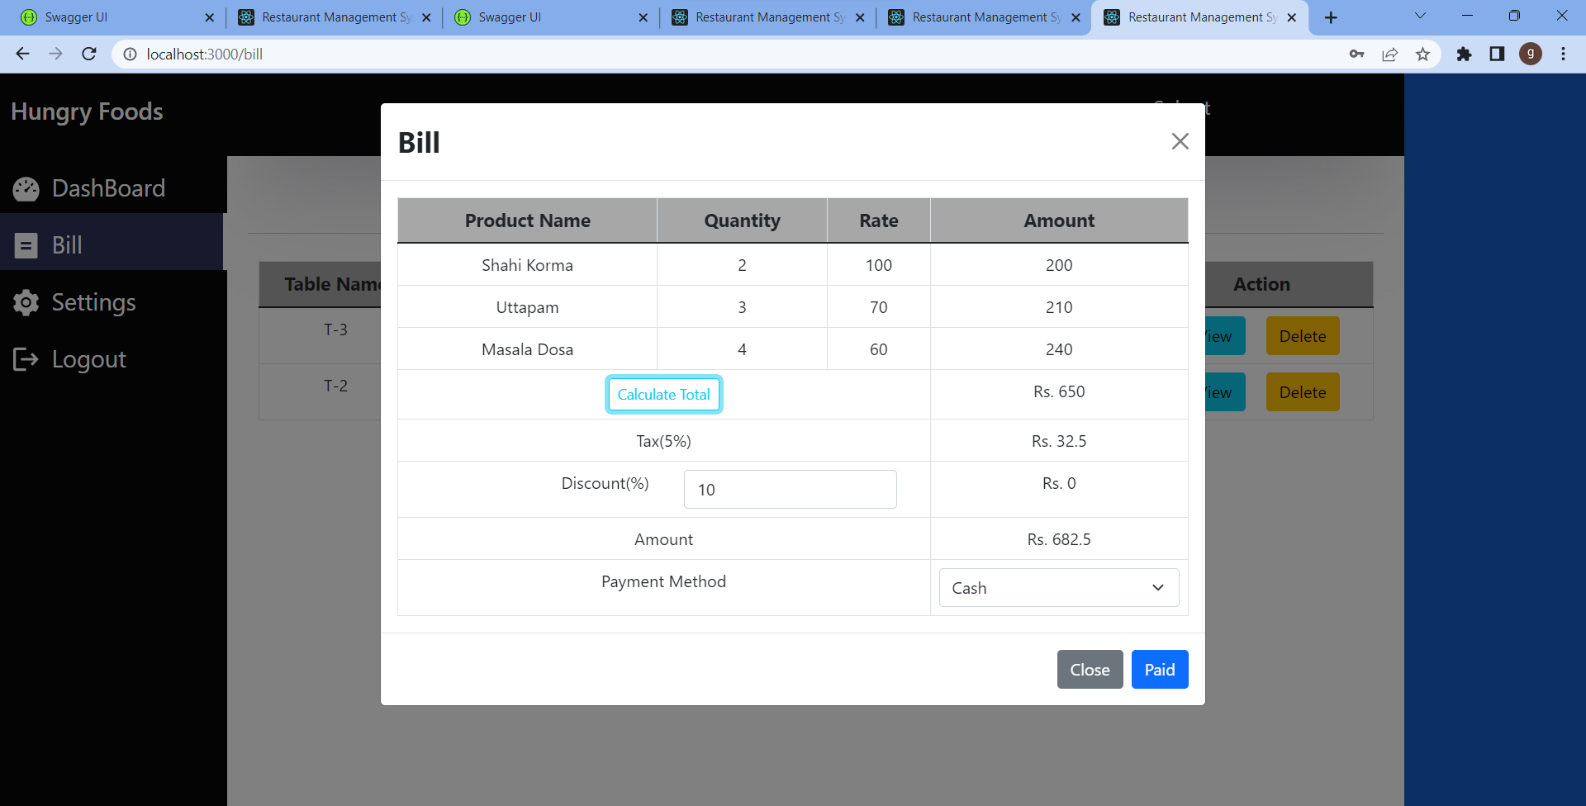

**PAYMENT DONE AFTER ORDER IS COMPLETED**

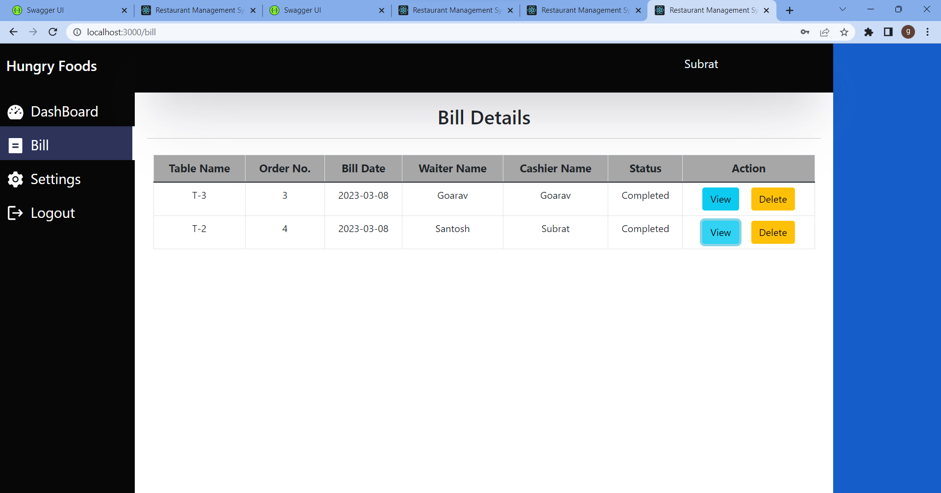

**PAYMENT REFLECTED IN DASHBOARD AFTER PAYMENT IS DONE & DASHBOARD SHOWS TODAYS ALL ORDERS IN RS**

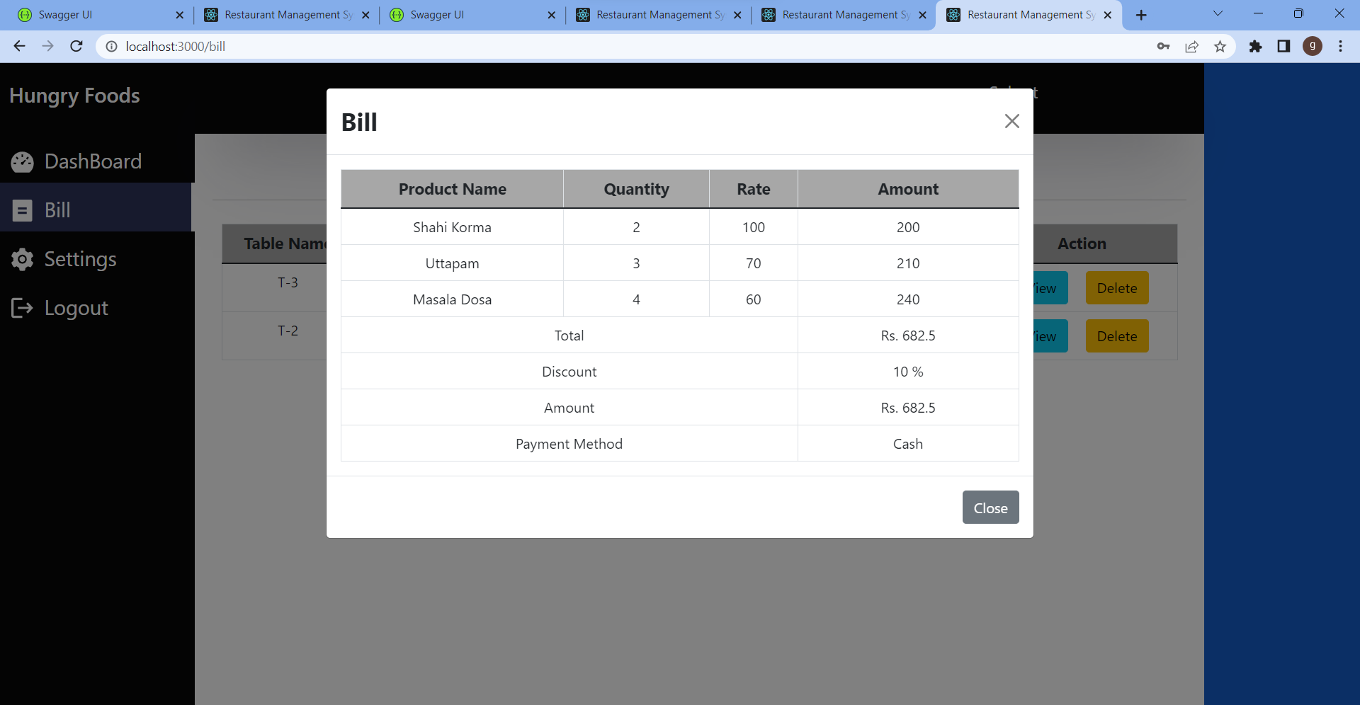

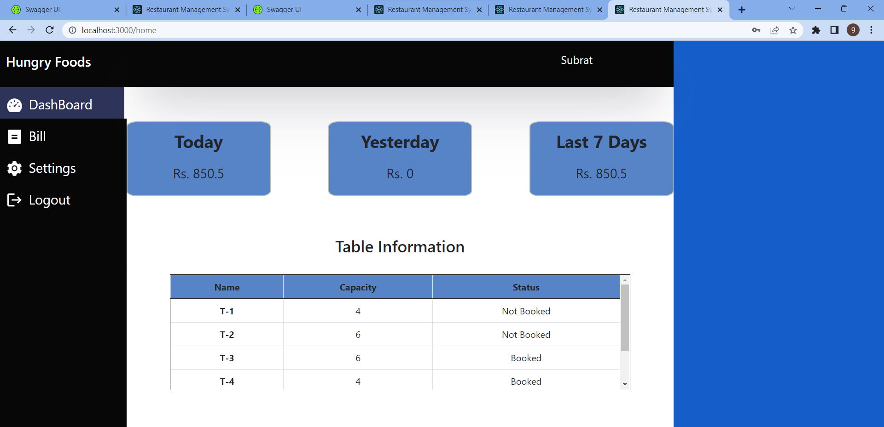

**ALL THE USERS(STAFF ) CAN LOGOUT FROM APPLICATION**

**FROM LOGOUT SECTION OF THEIR RESPECTIVELY UI**

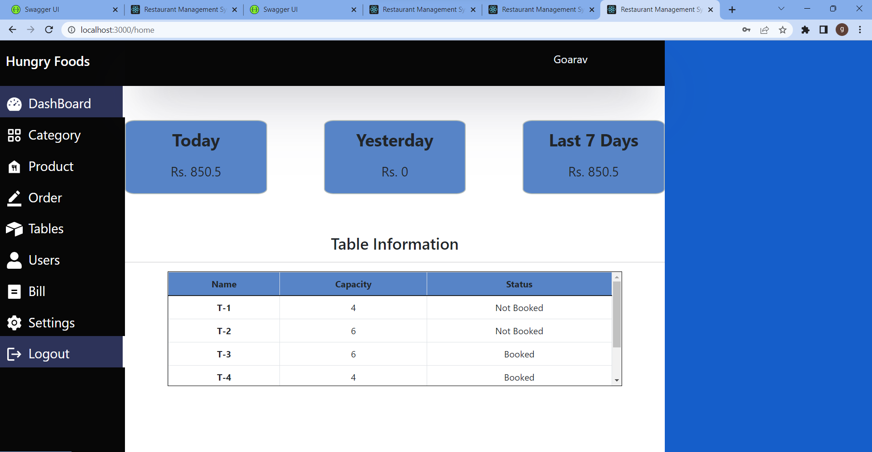

**CAHIER CAN ALSO CHANGE HIS PASSWORD / NAME /**

**USERID**

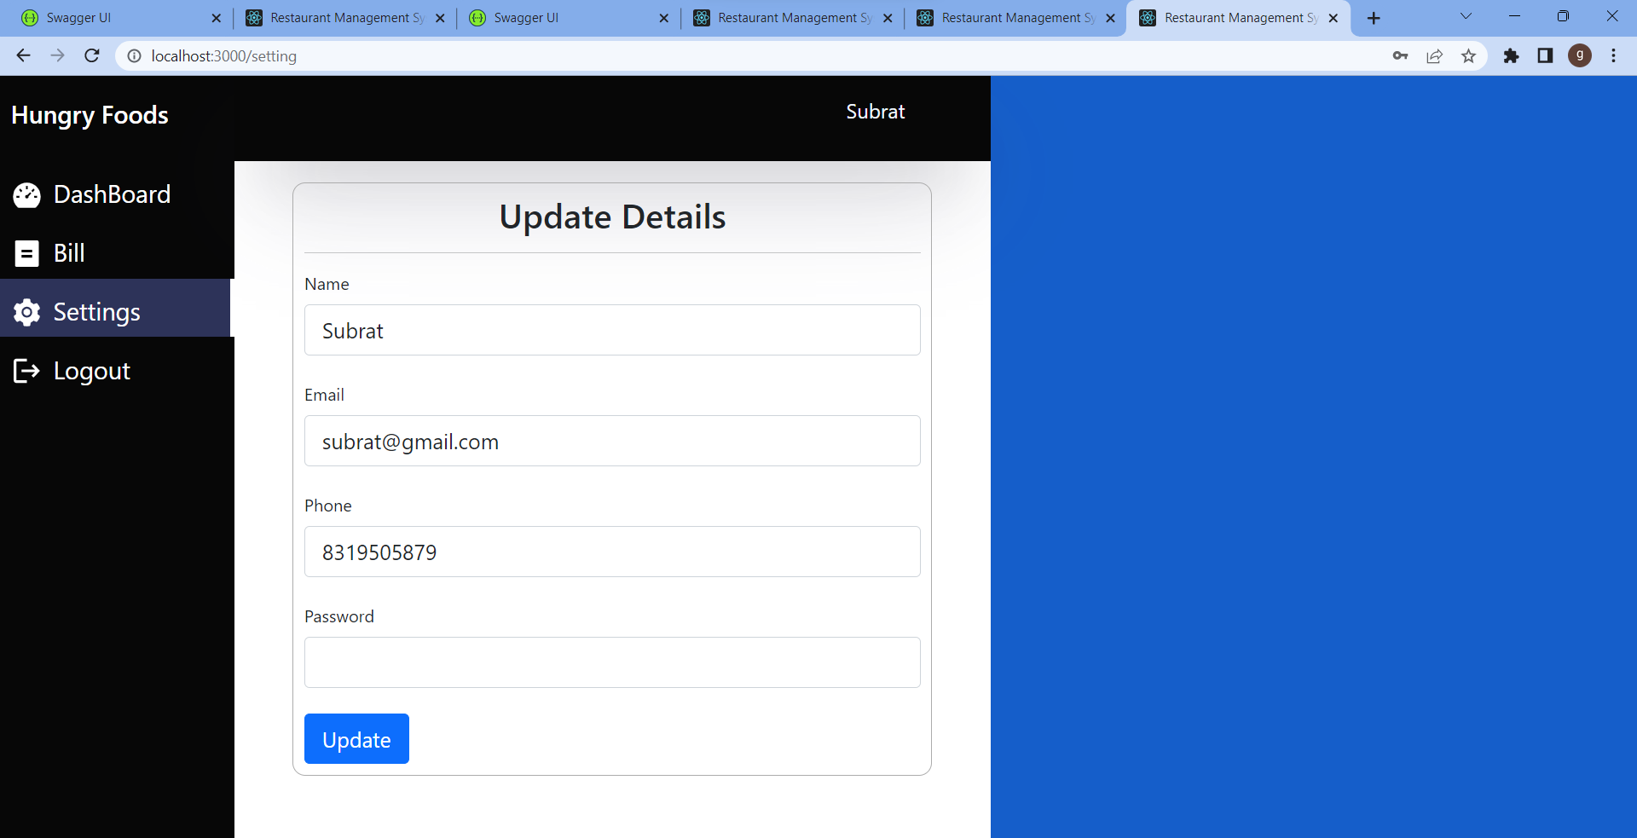

**6. Conclusion**

Restaurant management system puts forth the actual working of a restaurant. Staff management, food item and category management, bill management, order management, table management, etc. similar to a restaurant are the key features of our project. Staff person having their job can access different functionalities of the application to service the visited customer effectively and additionally manager can there to monitor the workflow of the whole restaurant.

**Future Scope**

As the saying goes, necessity is the mother of invention, and nothing spurs innovation in technology for better restaurant management we are comes with this application which will improve the customer experience , there is no confusion due to large number of orders because of this application .

Now in future we can add some additionally feature in this application like cloud kitchen , different type of online payment method and like home delivery options like feature we can add in future, this single application can use by restaurant to restaurant management , online food ordering , employees payroll management like everything related to restaurant we can manage A to Z .

In futures we can improve better UI so the user experience also becomes smothering.

95% of restaurant operators view the ability to improve guest satisfaction and the quality of the guest experience as one of the biggest benefits one can expect to gain with the right restaurant management

This system will help to manage the restaurant business systematically. In this management system, we will provide a web application that can be used by the Manager along with the staff of that restaurant to manage the food orders given by the customers, so that the manager of that restaurant can monitor and ensure the smooth conduct of the whole system.

This will lead to serving food faster and ultimately a better kitchen place to revisit it again. In addition to this, the system is capable of hiring different job roles required for a restaurant, the required information about staff will be saved in the system which can be only accessed by the system admin.

**7. References**

* JavaScript Enlightenment, Cody Lindley-First Edition, based on JavaScript 1.5, ECMA-262, Edition
* Mc Graw Hill’s, Java: The complete reference 7thEdition, Herbert Scheldt
* Complete CSS Guide, Maxine Sherrin and John Allsopp-O'ReillyMedia; September 2012

**ONLINE REFERENCE**

* IEEE recommended practices for SRS. ANSI / IEEE Std 830 – 1993.
* <https://www.geeksforgeeks.org/levels-in-data-flow-diagrams-dfd/>
* www.javatpoint.com/
* <https://www.w3schools.com/> :- online tutorials website.